**SE3050**

**User Experience Engineering**

**Lab sheet 6**



**Group ID: 2021S2_REG_WE_57**

|  |  |
| --- | --- |
| **Registration Number** | **Name** |
| IT19014128 | A.M.W.W.R.L. Wataketiya |
| IT19180526 | S.A.N.L.D. Chandrasiri |
| IT19240848 | H.G. Malwatta |
| IT19057248 | G.L.I.R. Liyanage |

Table of Contents

Sketching 3

IT19014128 (A.M.W.W.R.L. Wataketiya) 3

Sketches version 1 and 2 3

Version 3 10

IT19180526 (S.A.N.L.D. Chandrasiri) 15

IT19240848 (H.G. Malwatta) 20

IT19057248 (G.L.I.R. Liyanage) 28

Wireframes 33

IT19014128 (A.M.W.W.R.L. Wataketiya) 33

IT19180526 (S.A.N.L.D. Chandrasiri) 36

IT19240848 (H.G. Malwatta) 41

IT19057248 (G.L.I.R. Liyanage) 45

Prototype Version 1 47

IT19014128 (A.M.W.W.R.L. Wataketiya) 47

IT19180526 (S.A.N.L.D. Chandrasiri) 51

IT19240848 (H.G. Malwatta) 59

IT19057248 (G.L.I.R. Liyanage) 63

User feedback 66

General 66

IT19014128 (A.M.W.W.R.L. Wataketiya) 66

IT19180526 (S.A.N.L.D. Chandrasiri) 66

IT19240848 (H.G. Malwatta) 67

IT19057248 (G.L.I.R. Liyanage) 67

Prototype version 2 68

IT19014128 (A.M.W.W.R.L. Wataketiya) 68

IT19180526 (S.A.N.L.D. Chandrasiri) 72

IT19240848 (H.G. Malwatta) 80

IT19057248 (G.L.I.R. Liyanage) 85

Contributions 89

# Sketching

## IT19014128 (A.M.W.W.R.L. Wataketiya)

### Sketches version 1 and 2

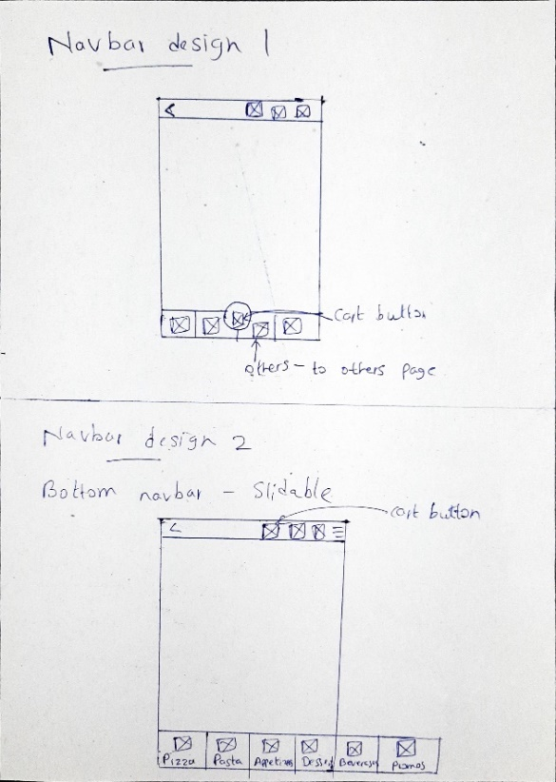

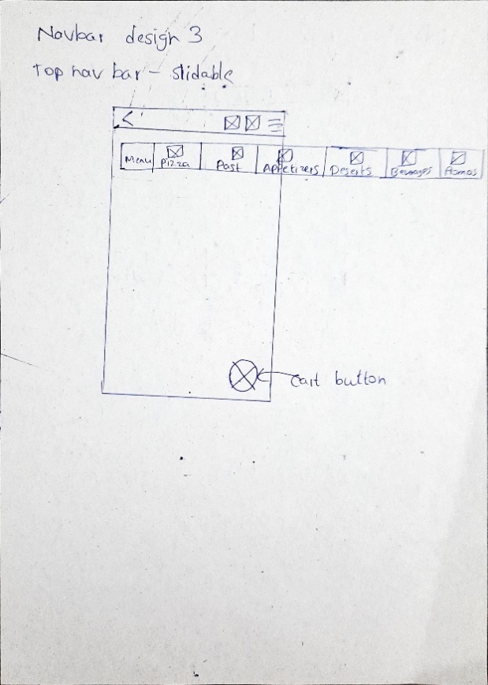

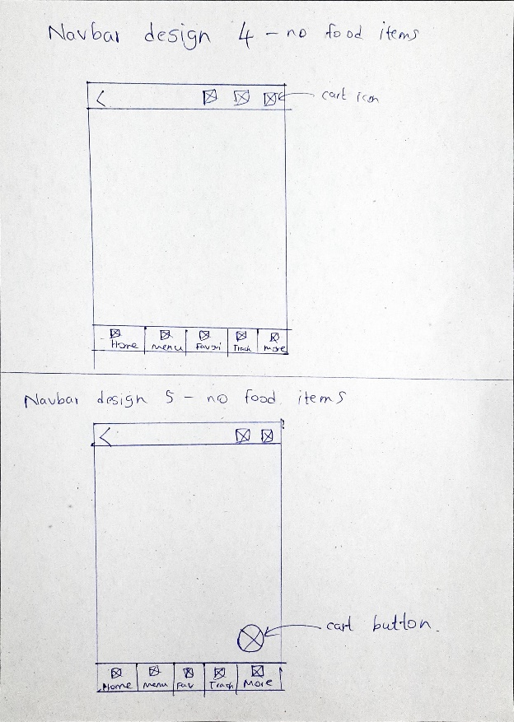

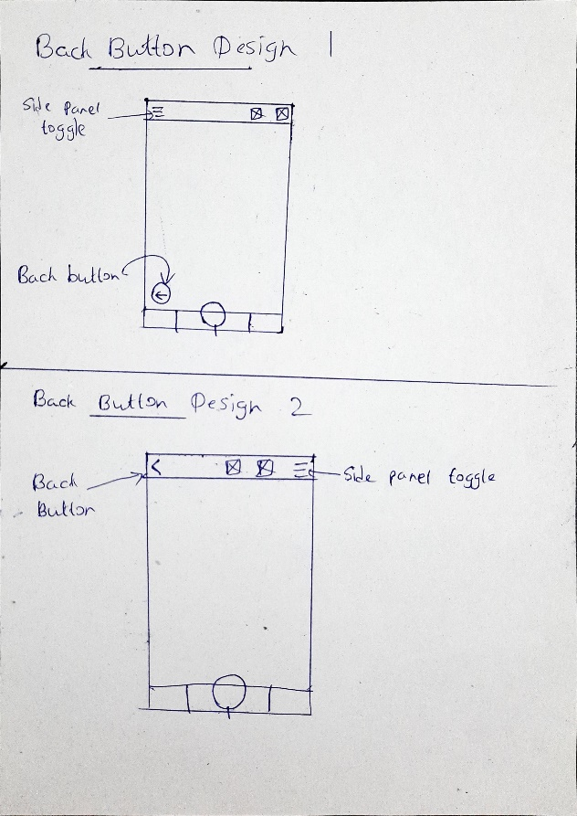

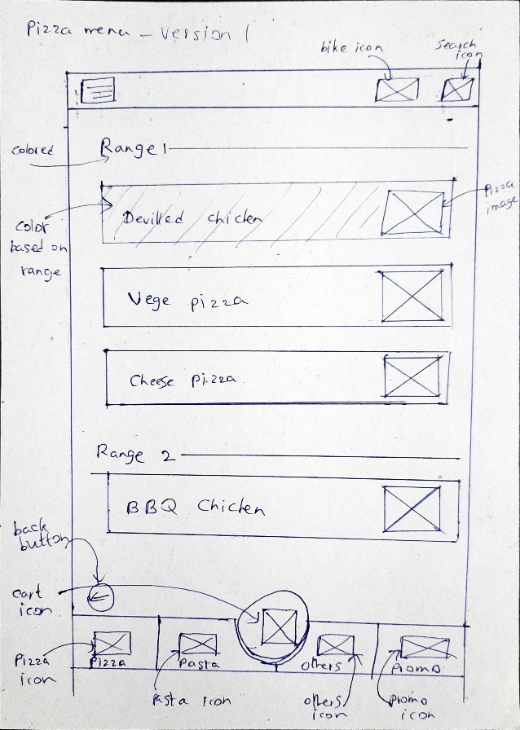

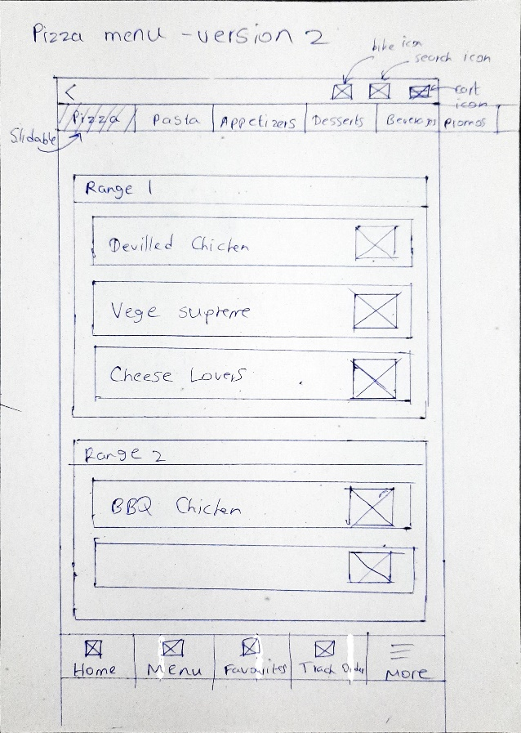

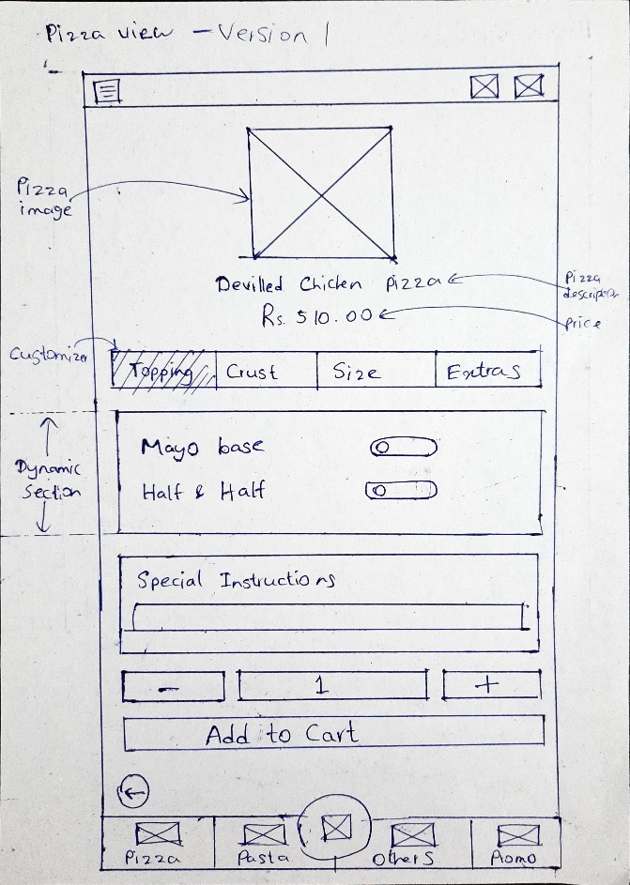

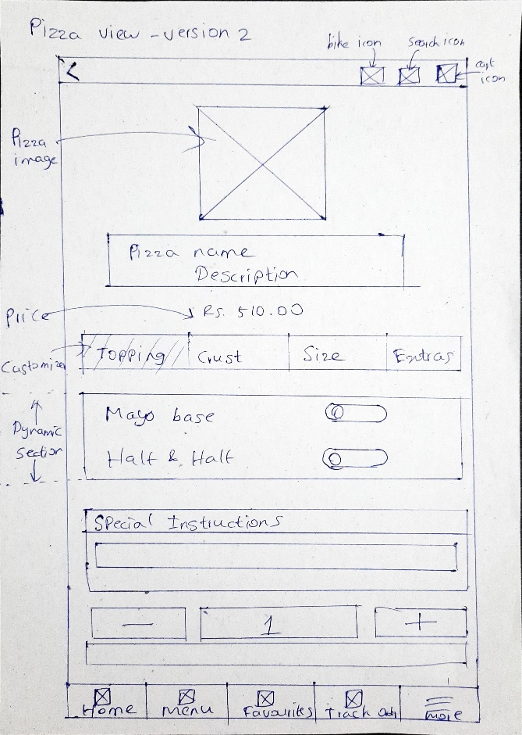

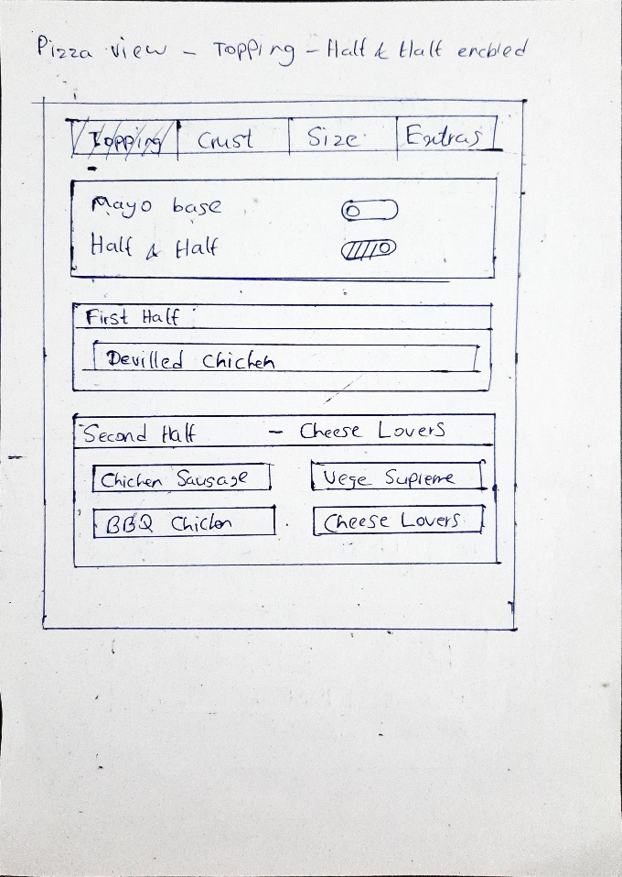

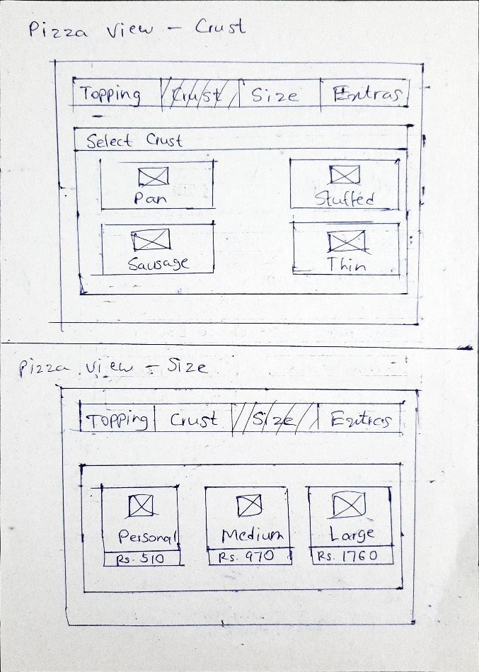

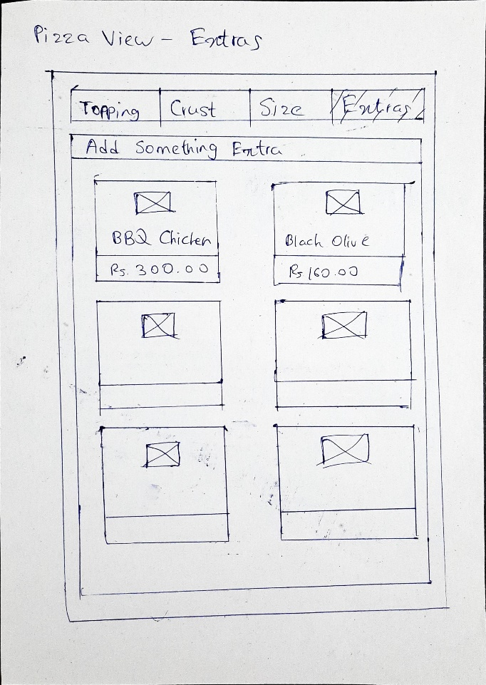

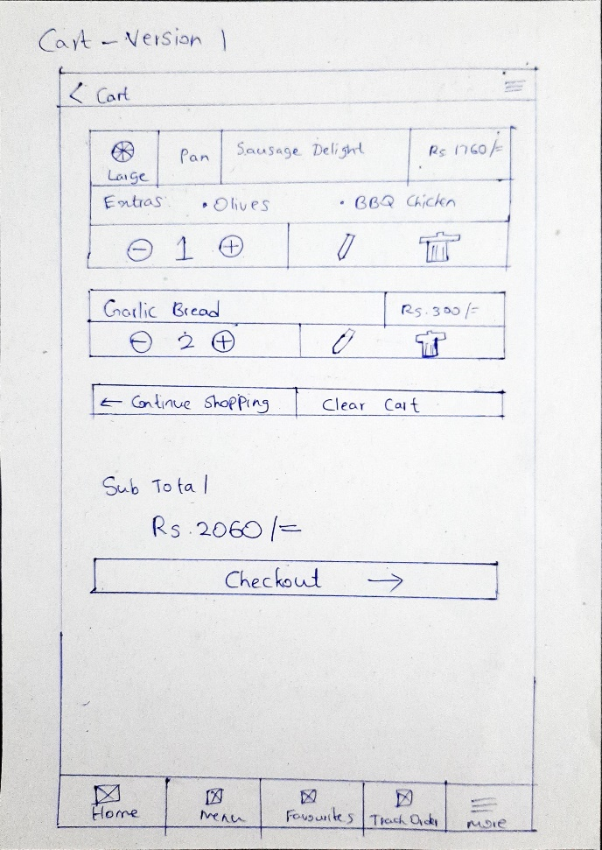

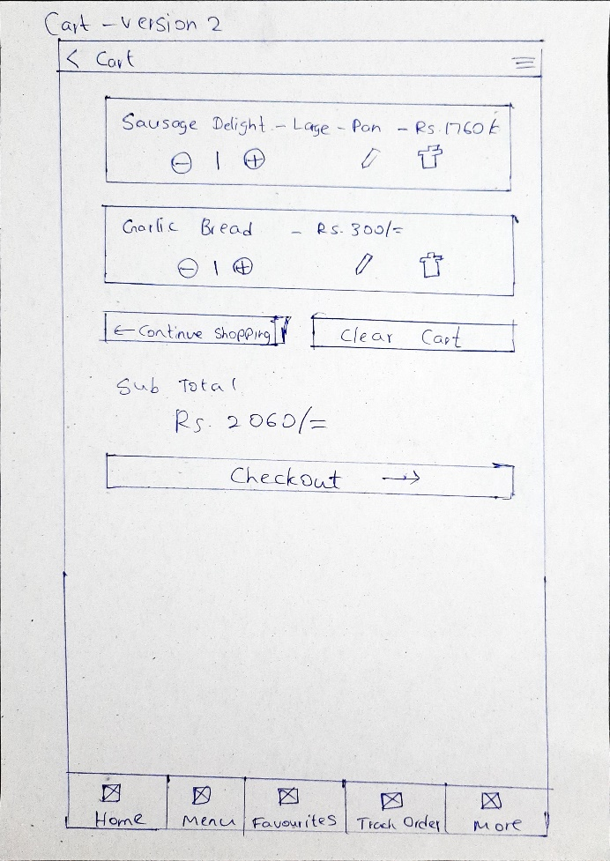

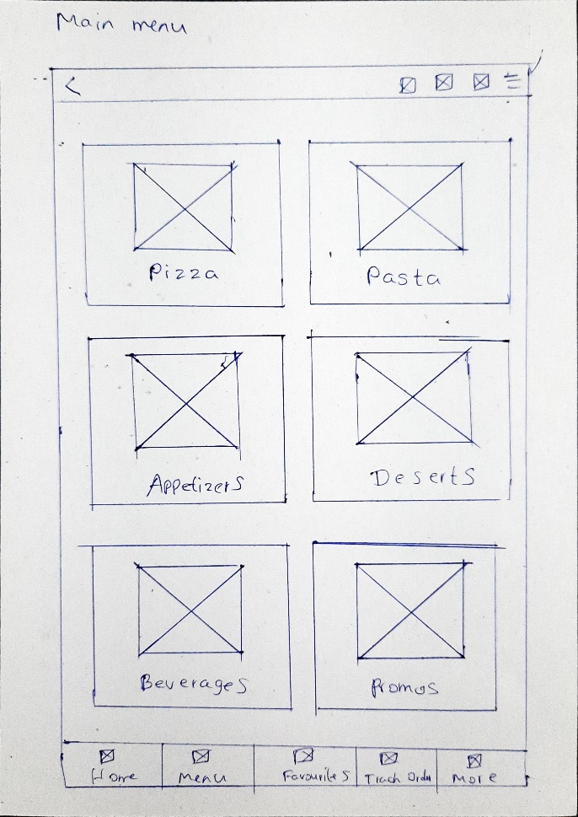

### Version 3

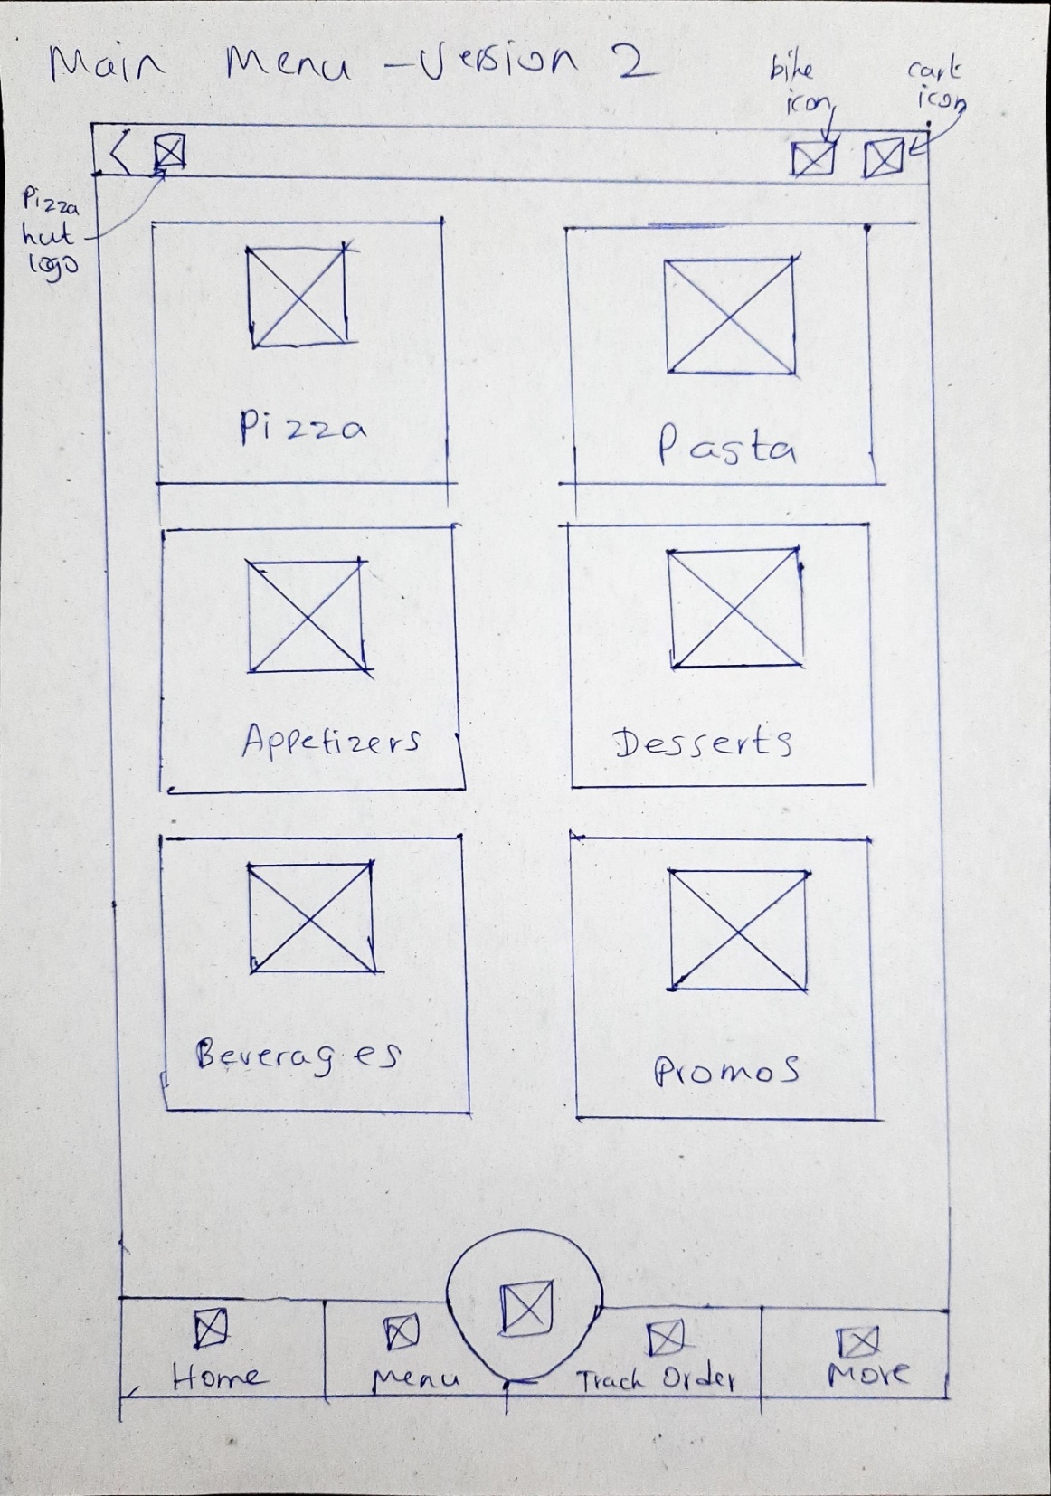

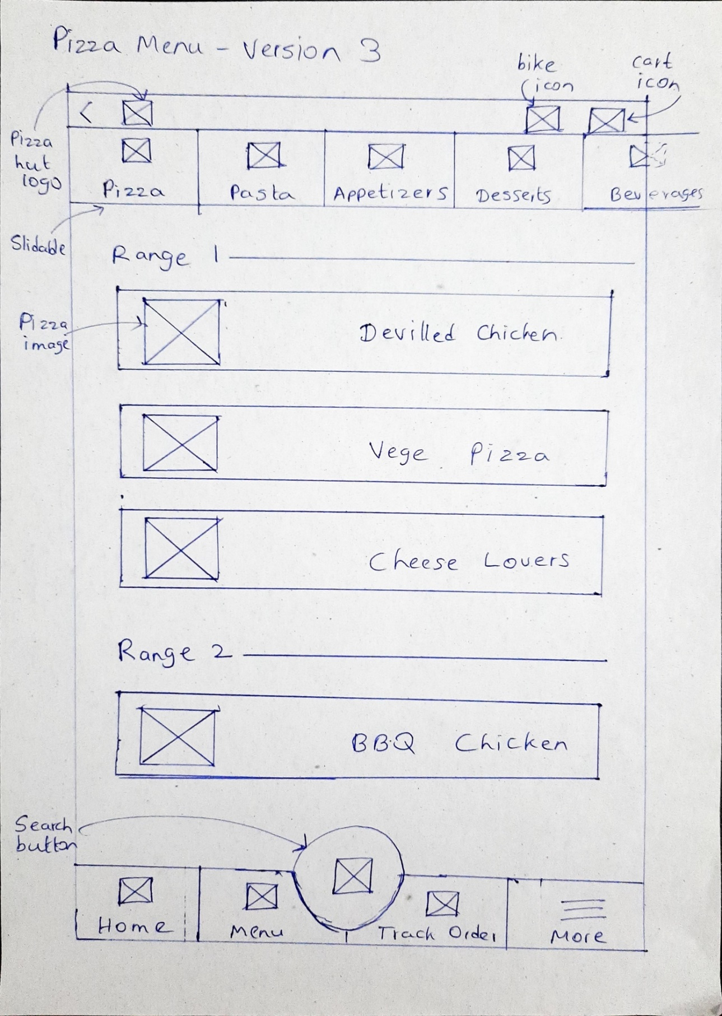

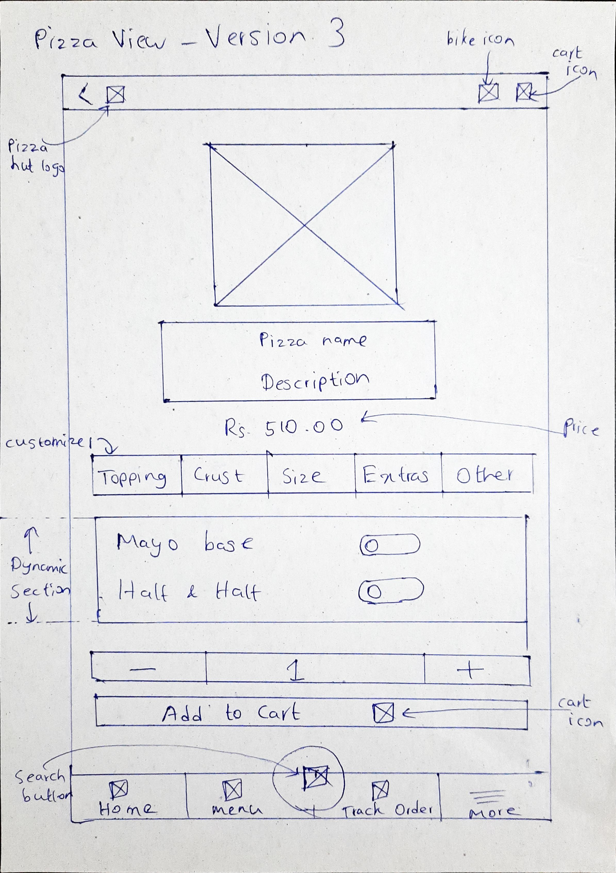

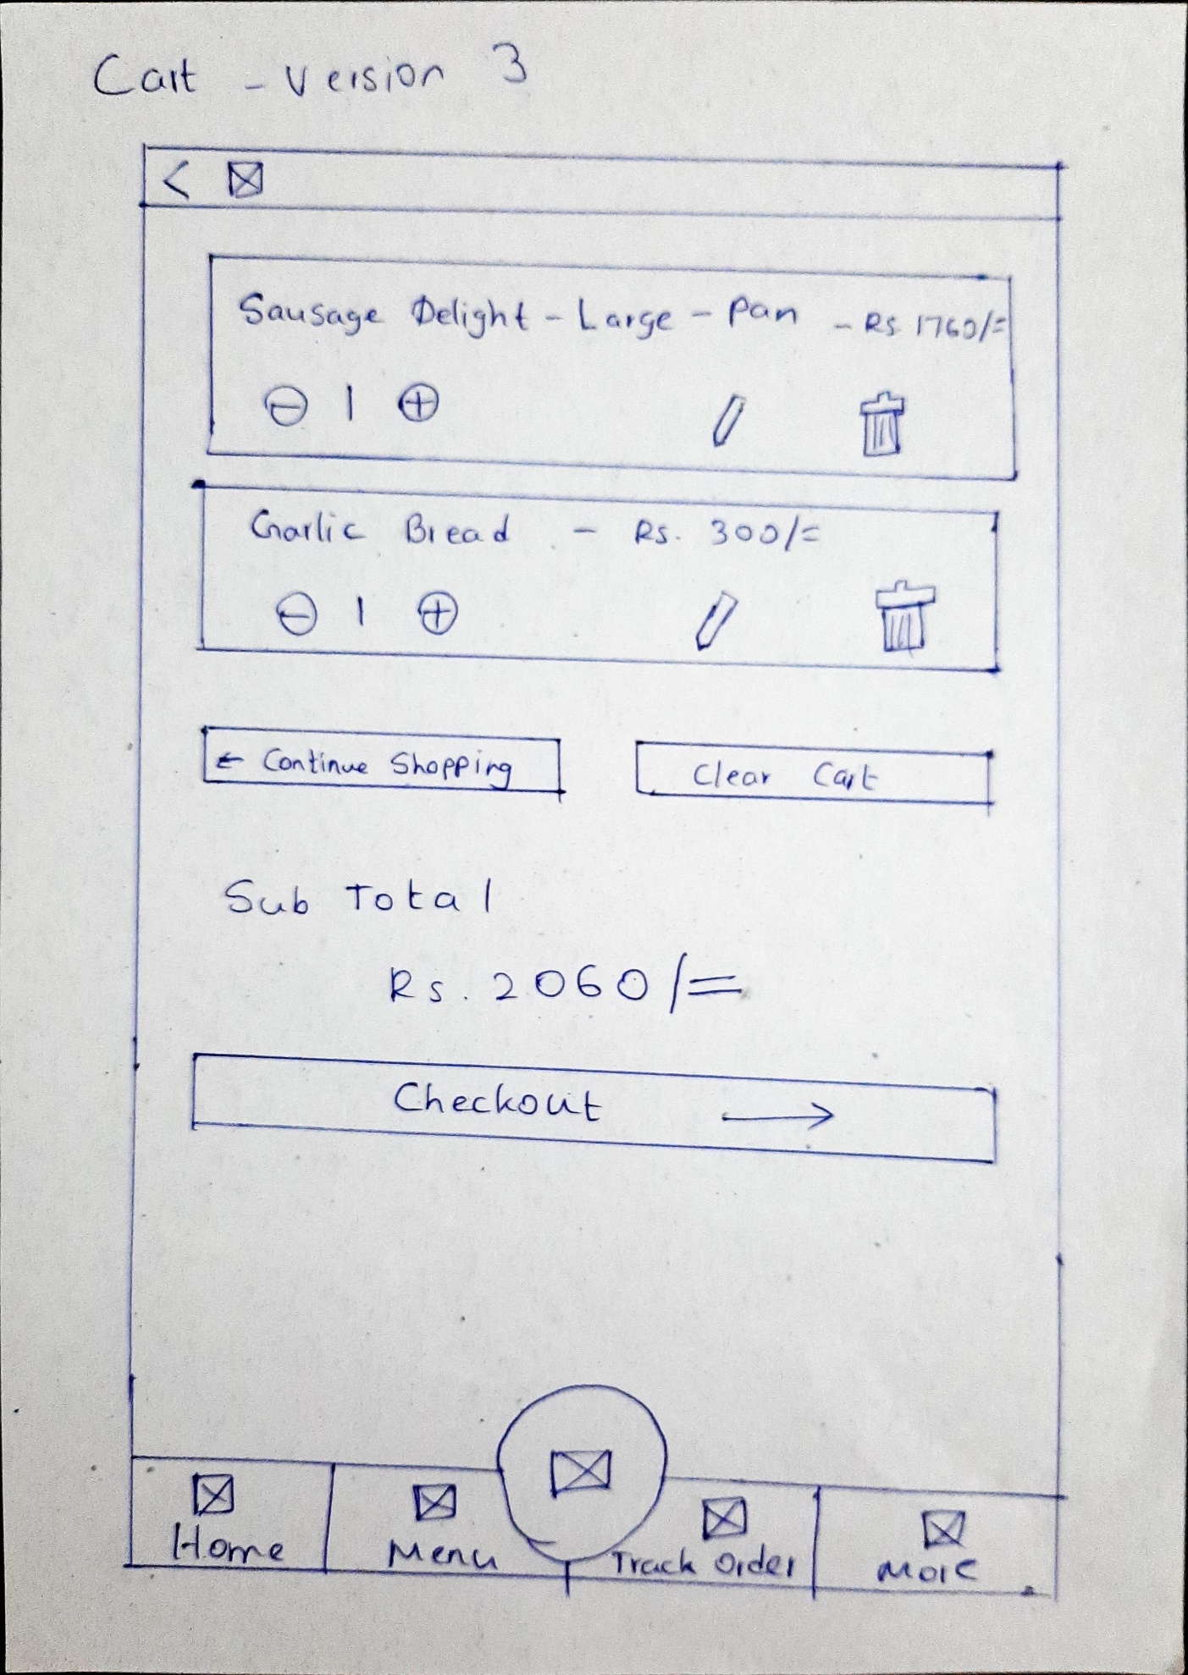

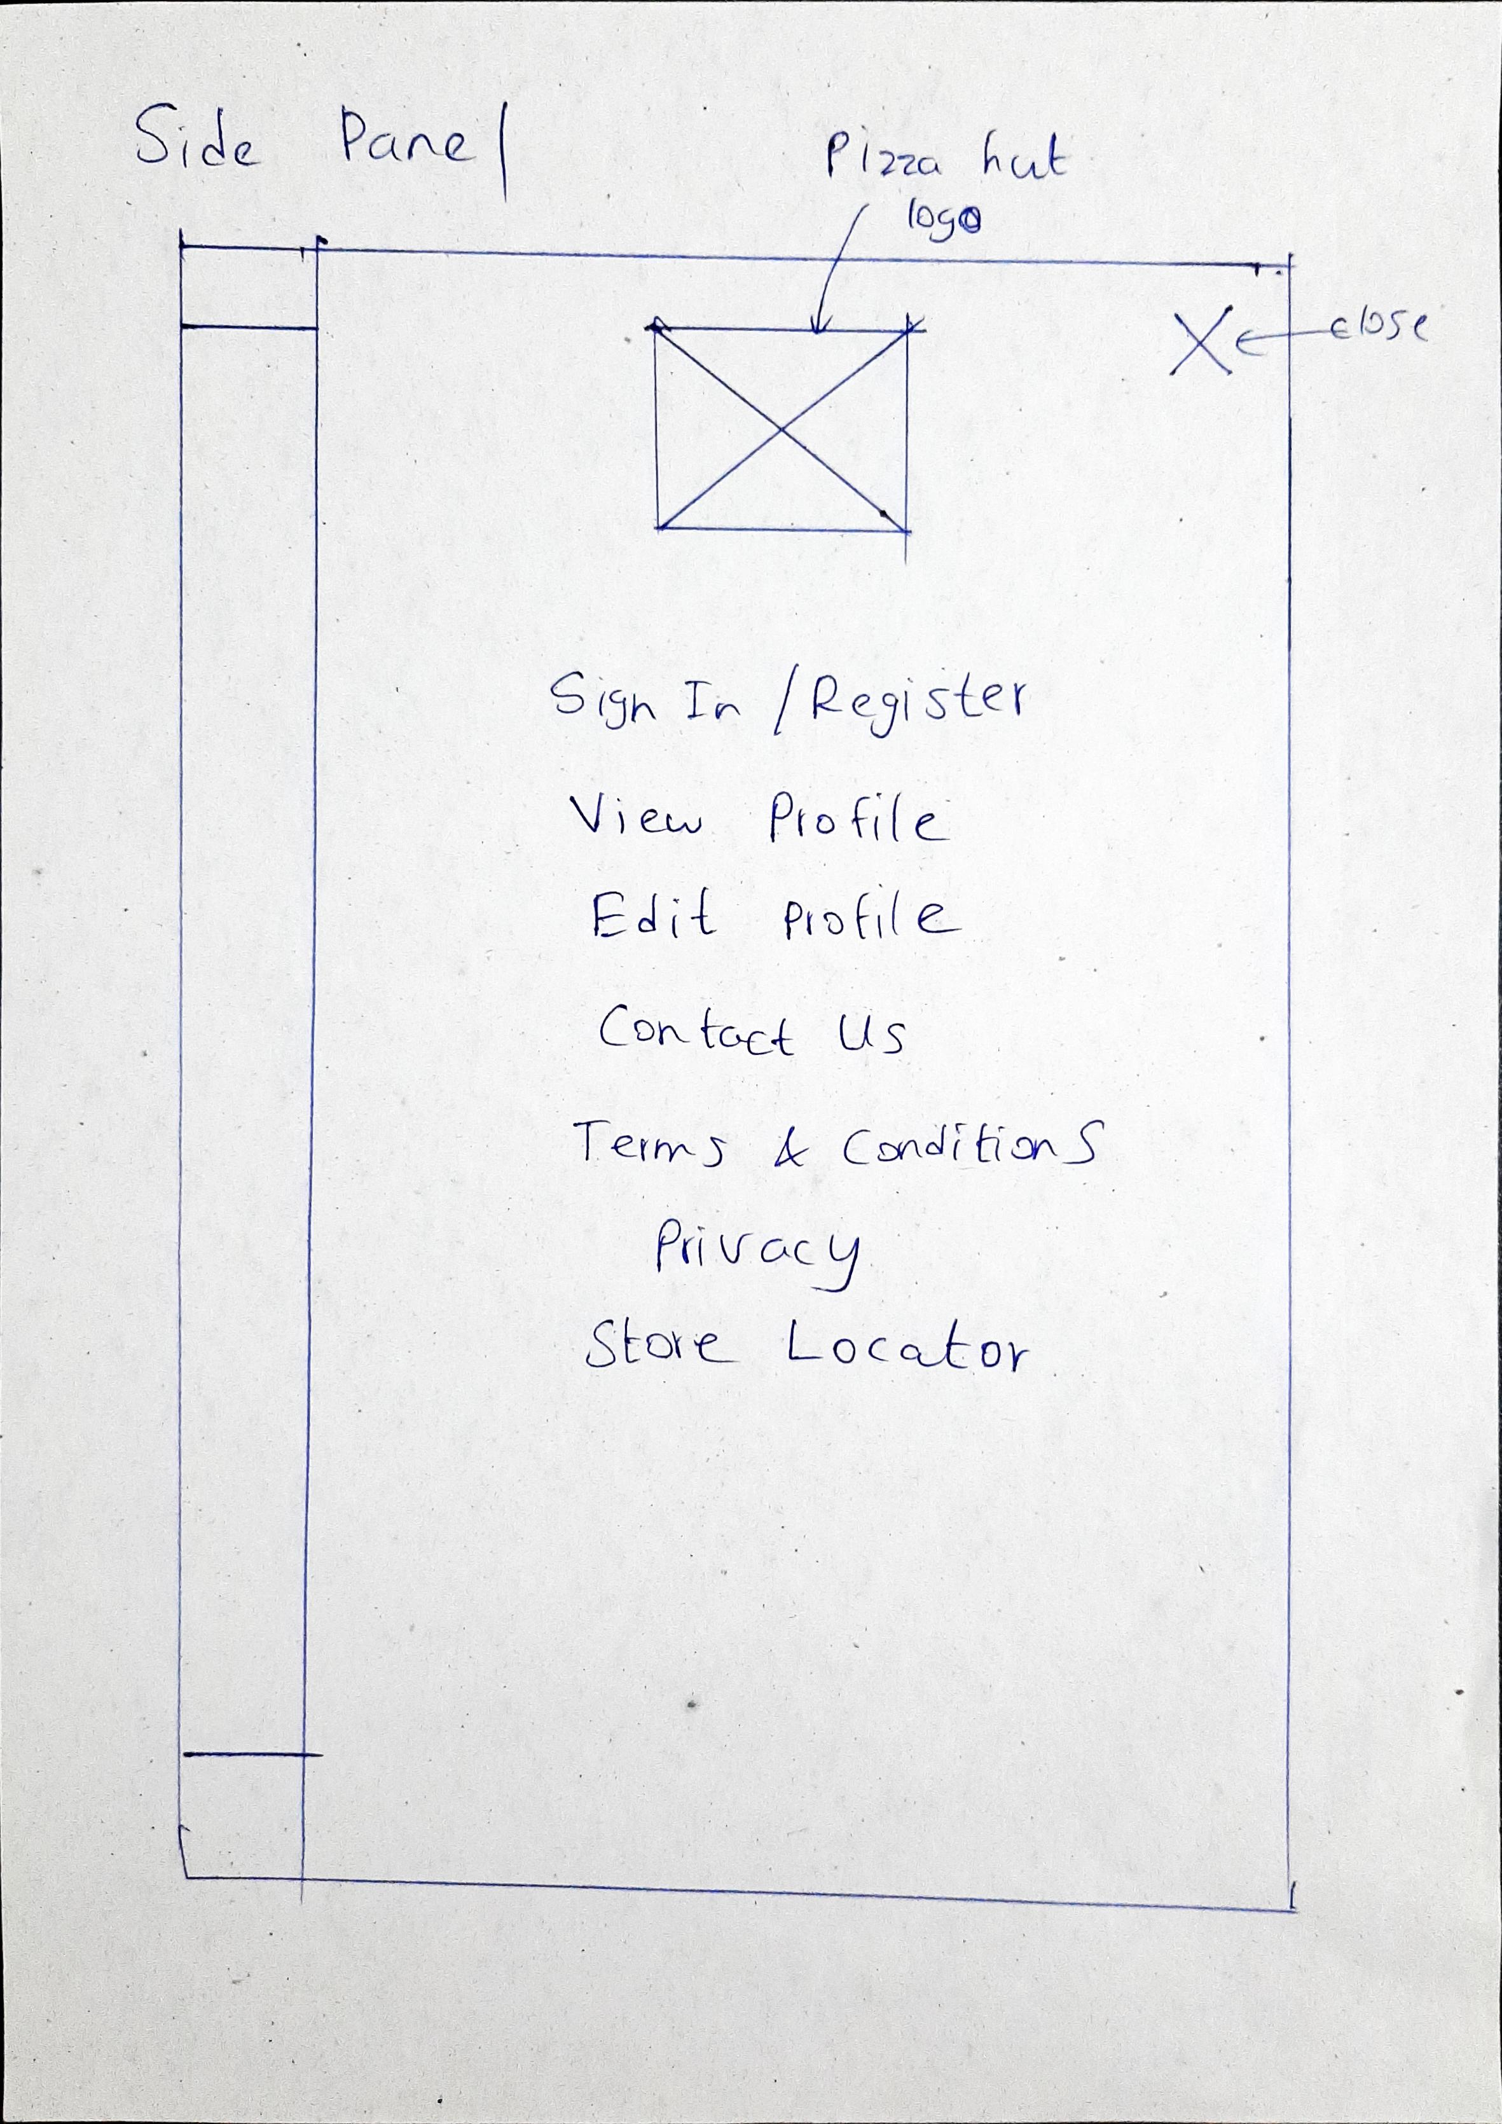

## IT19180526 (S.A.N.L.D. Chandrasiri)

Sketch Version 1.0

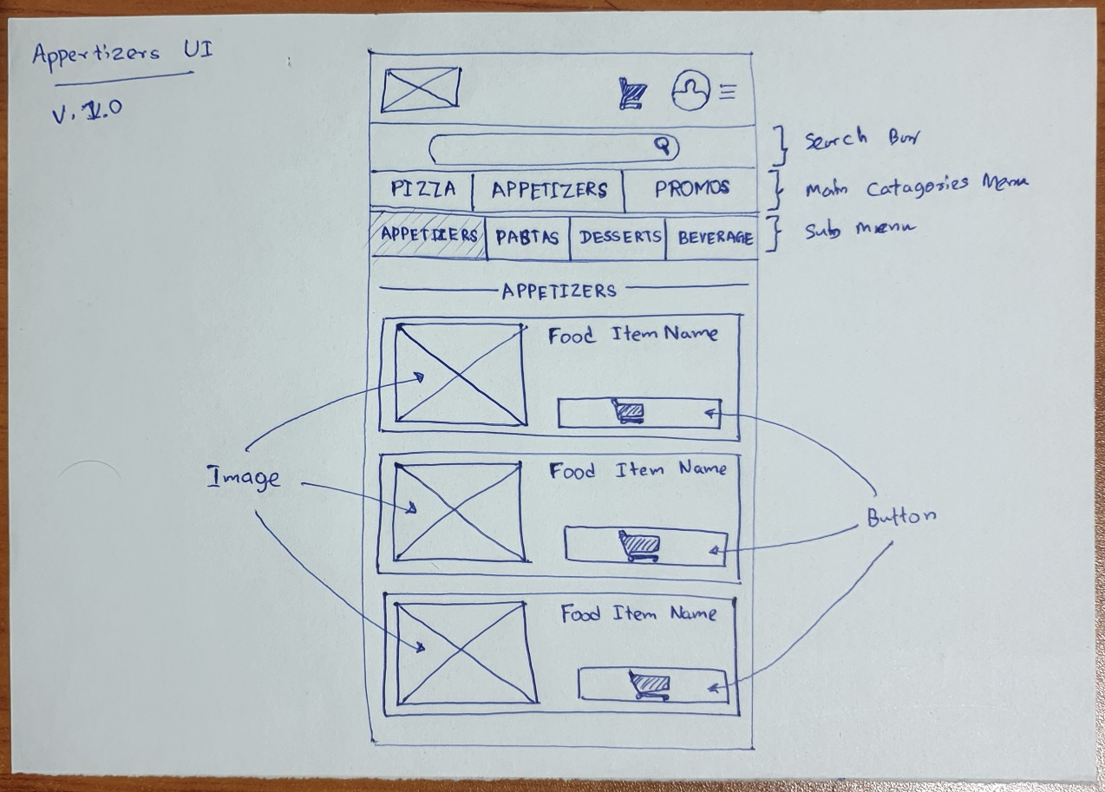

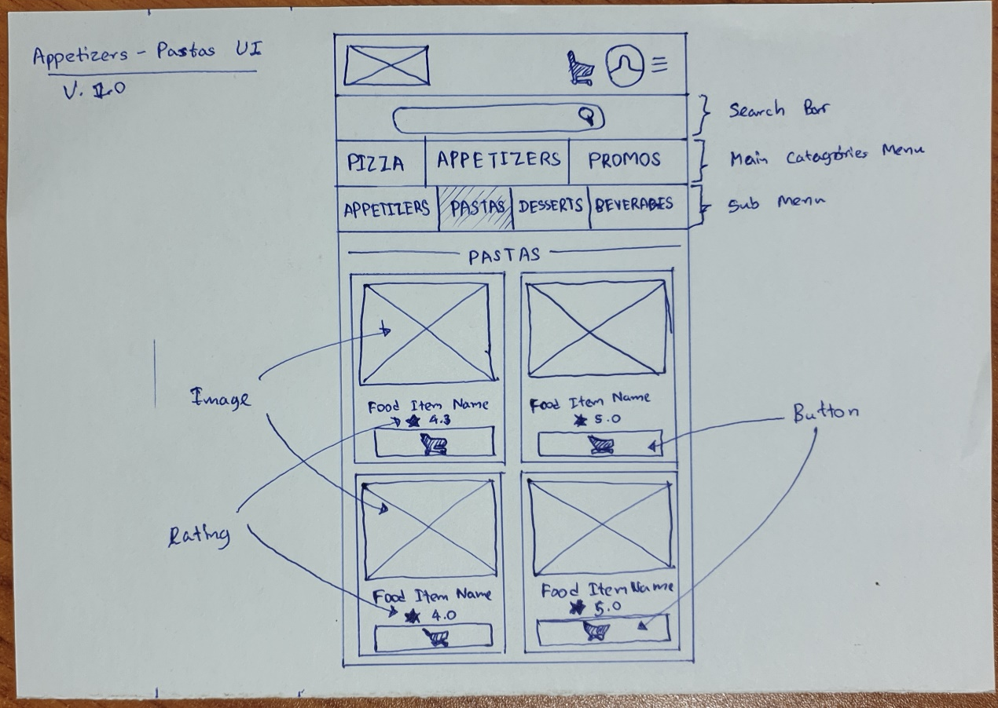

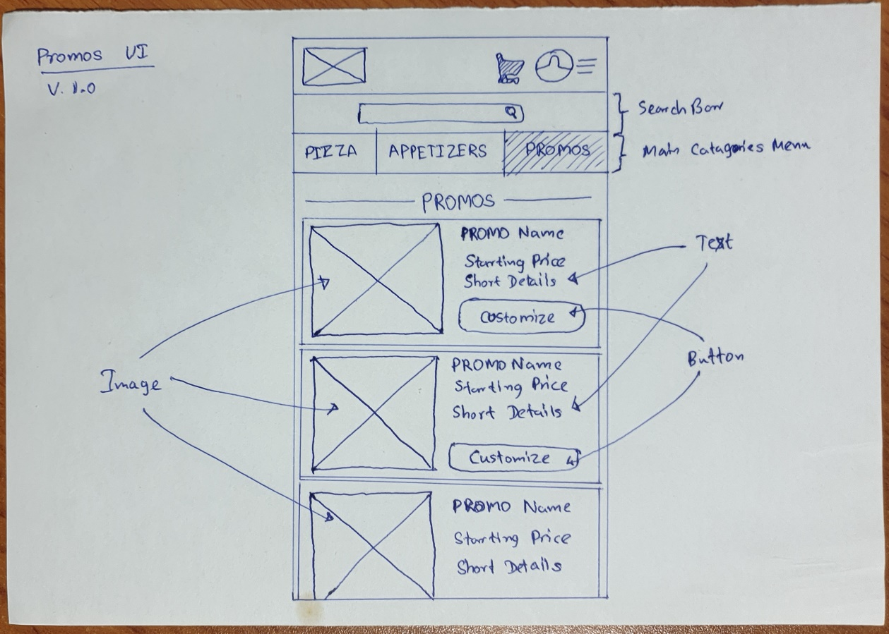

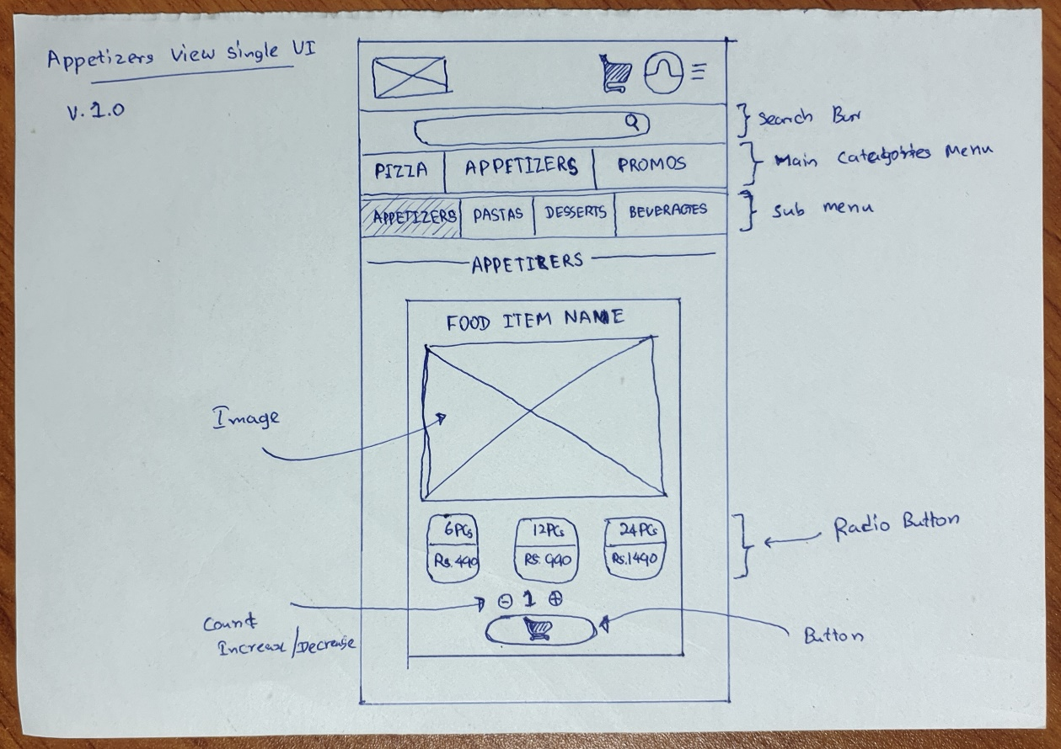

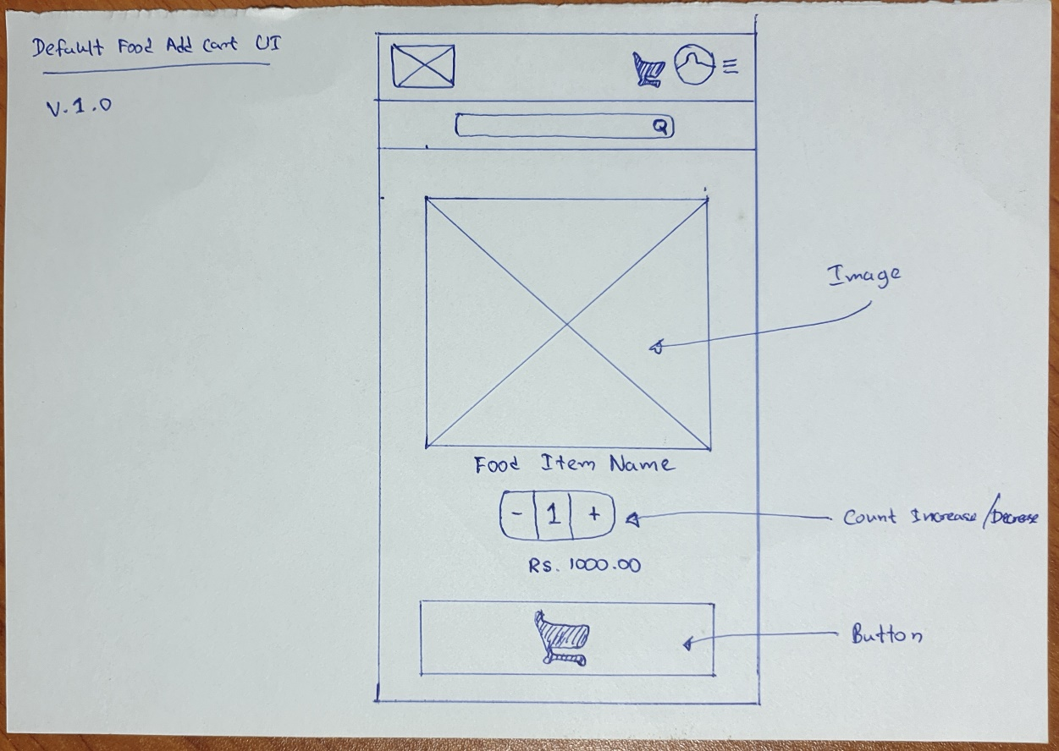

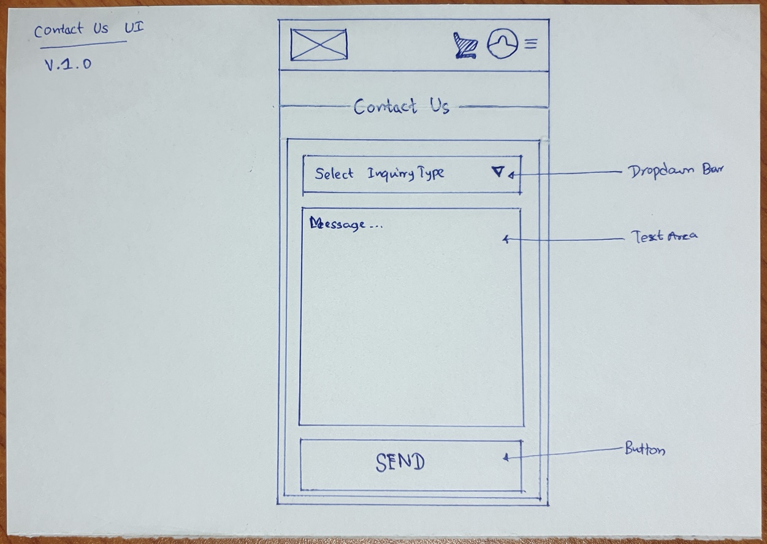

Sketch Version 2.0

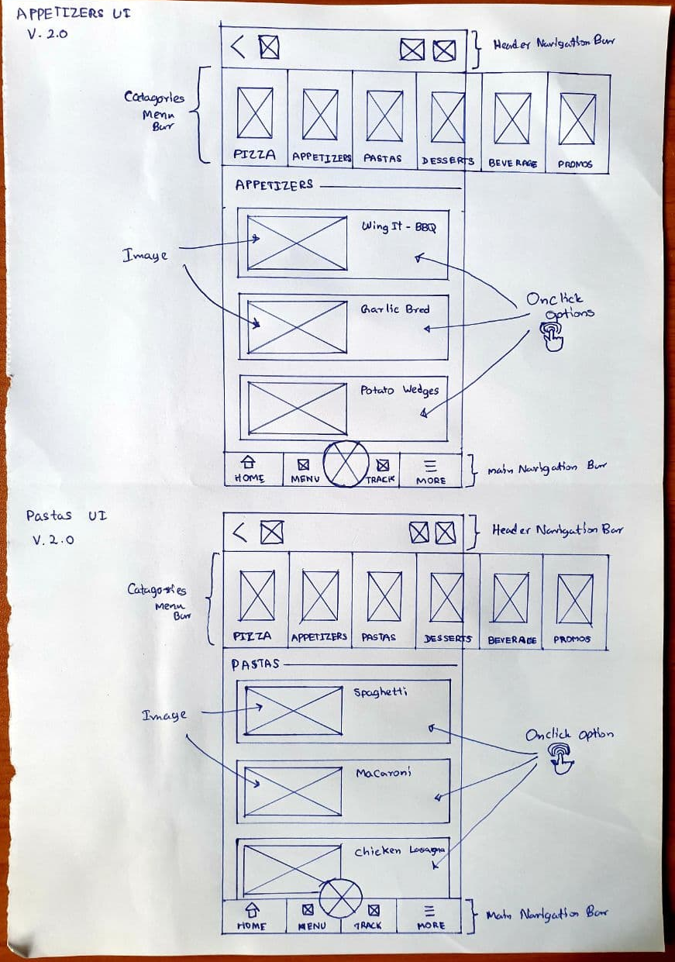

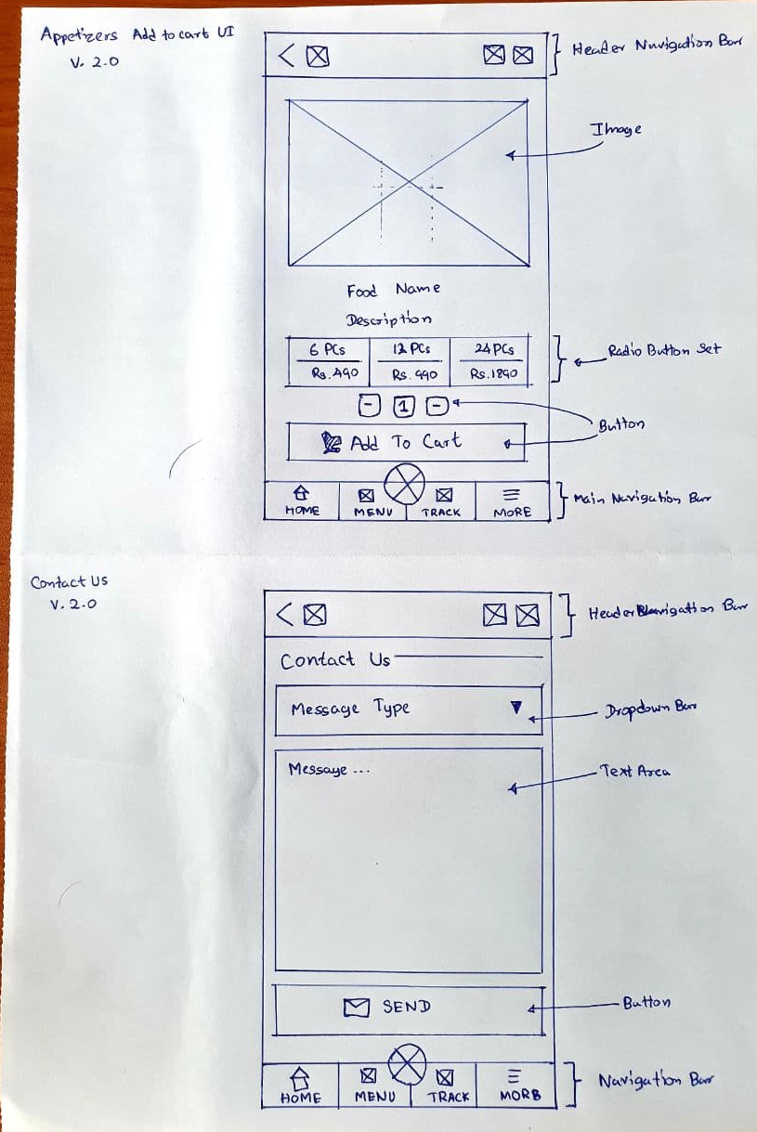

## IT19240848 (H.G. Malwatta)

Sketch Version 1.0

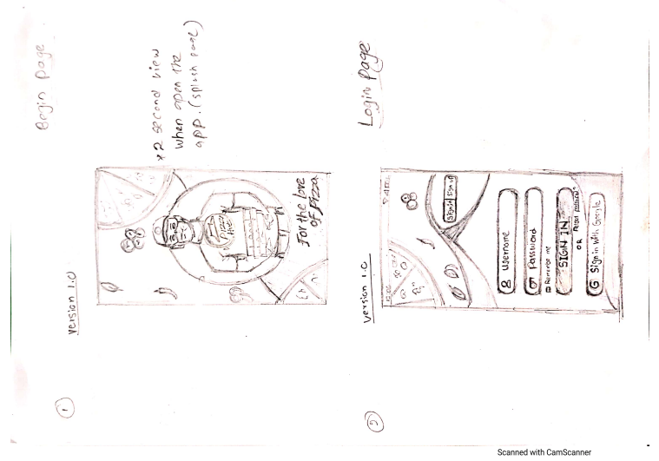

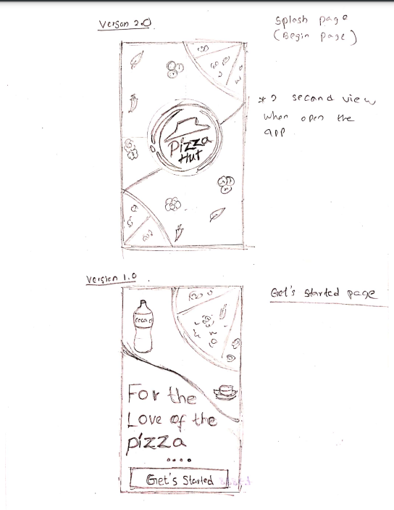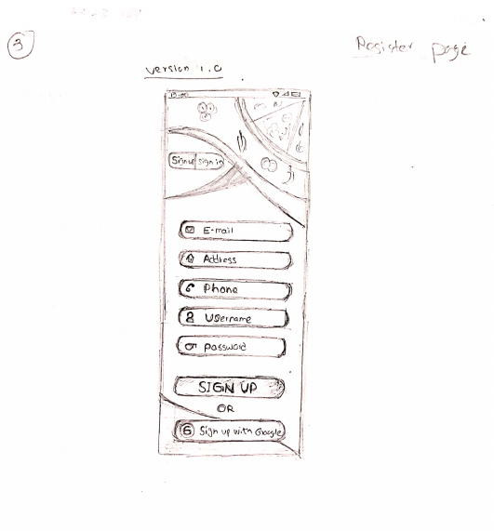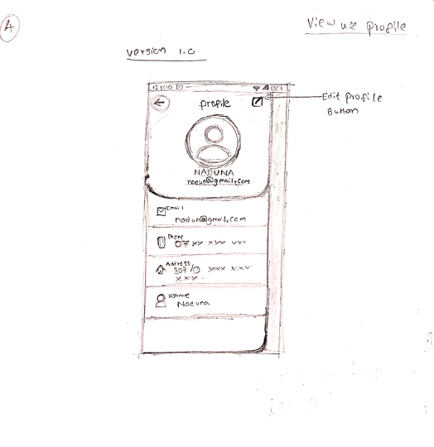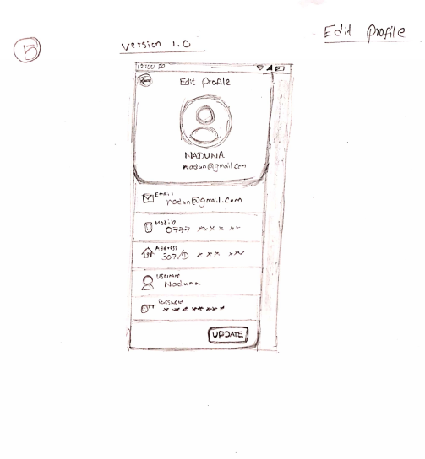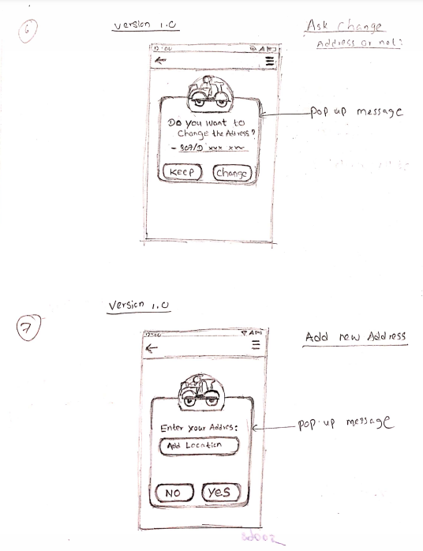

Sketch Version 2.0



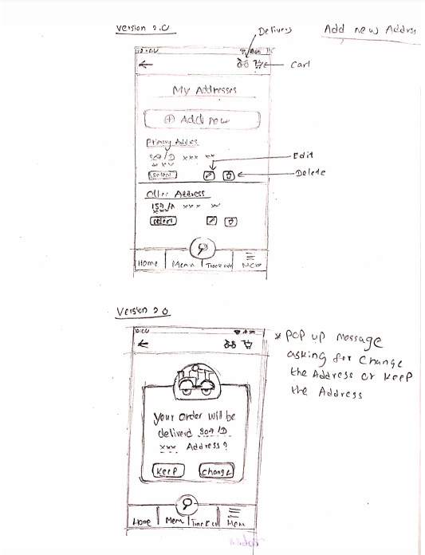

## IT19057248 (G.L.I.R. Liyanage)

Sketches

1. 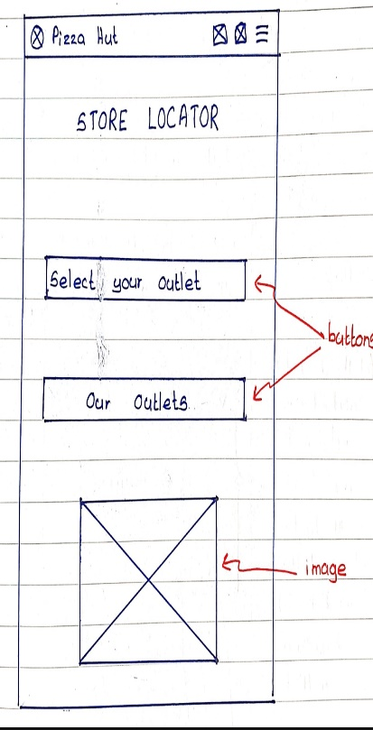Store Locator

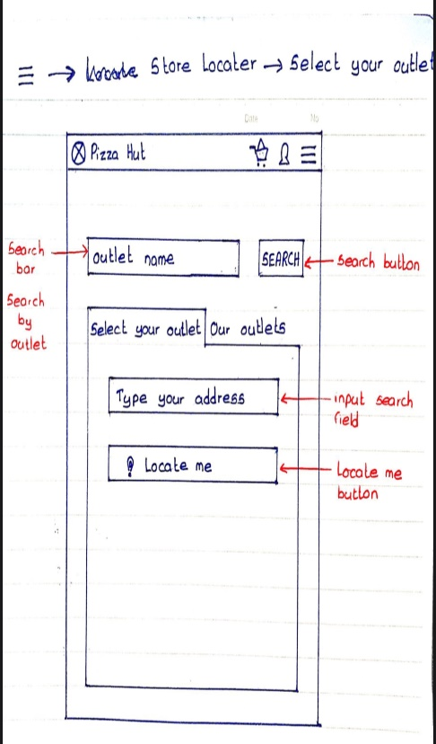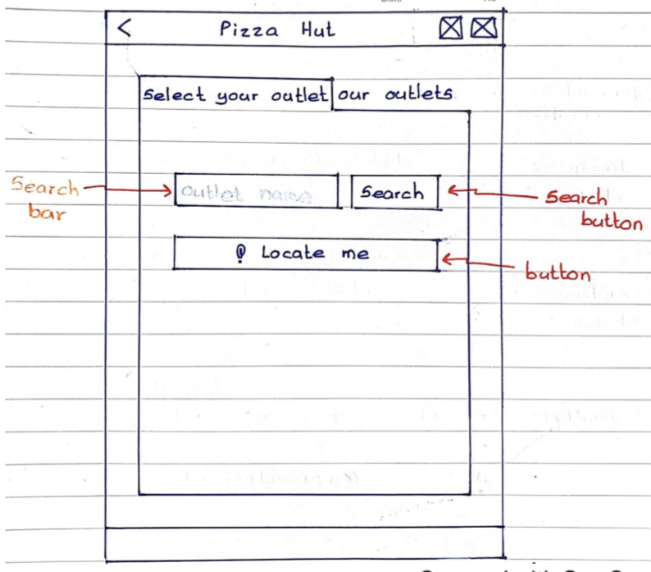

1. 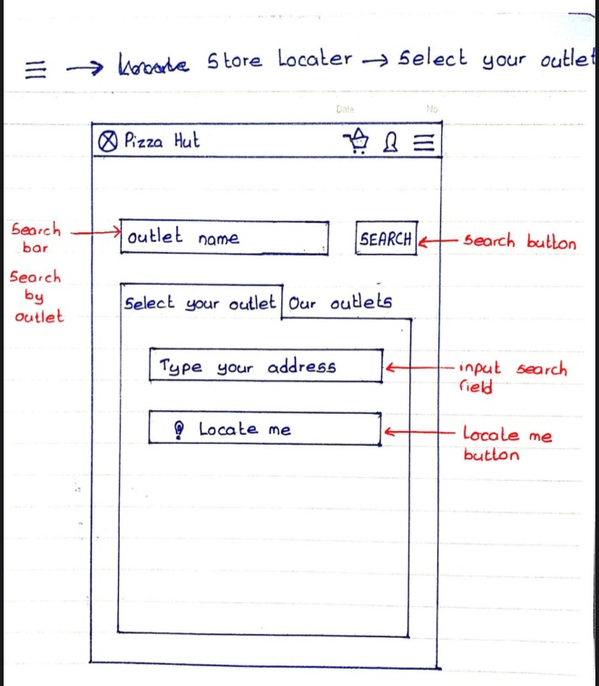.Select your outlet



1. 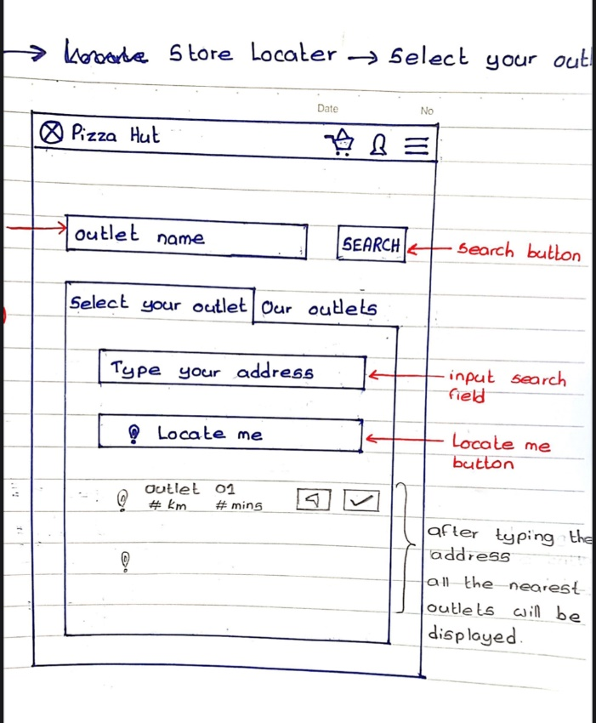Search outlet

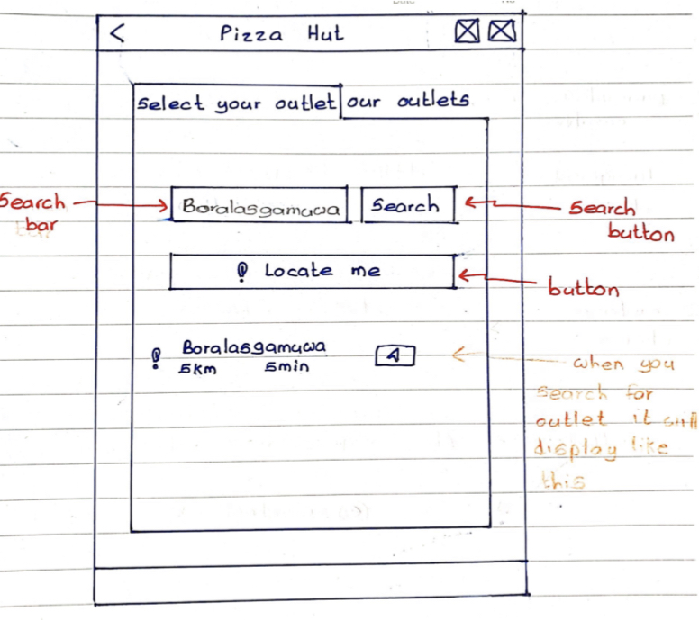

1. 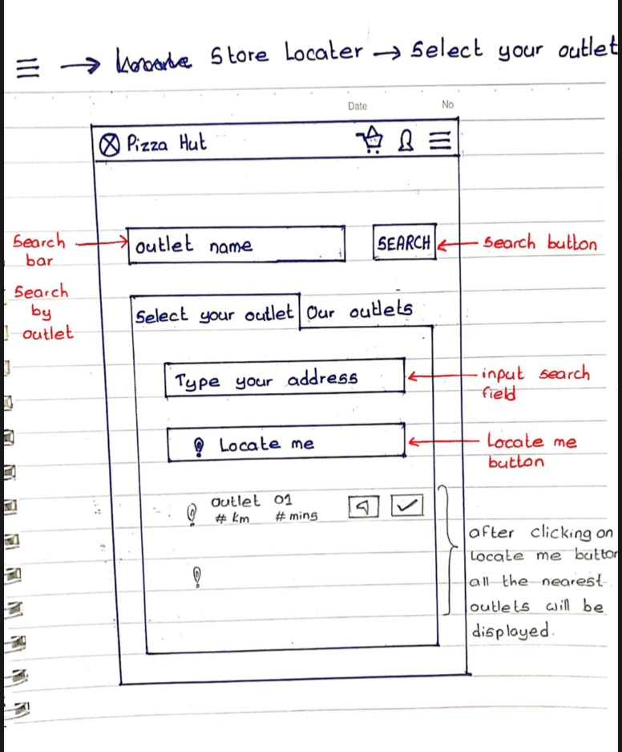Locate me

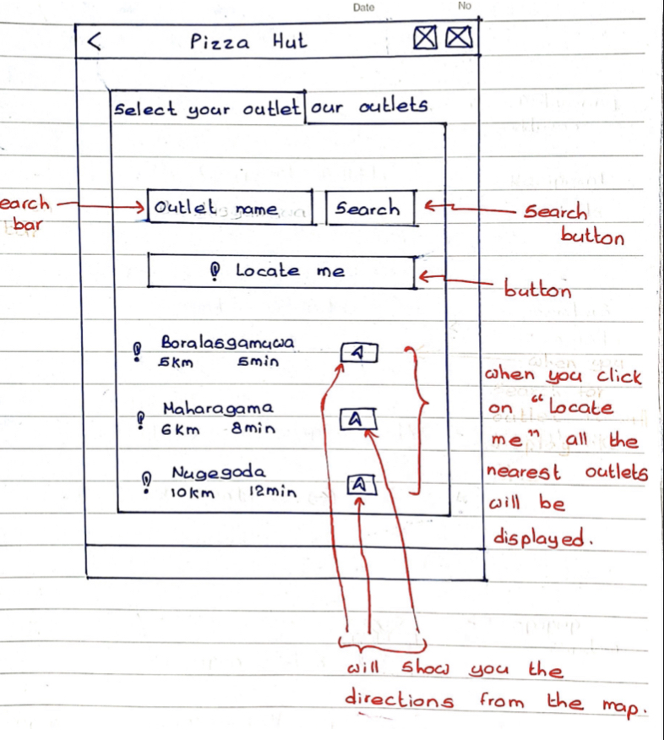

1. 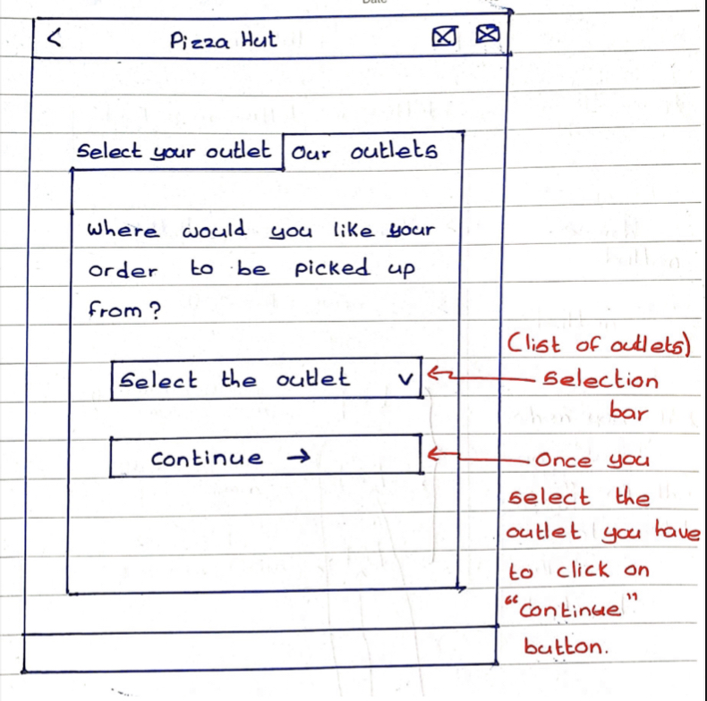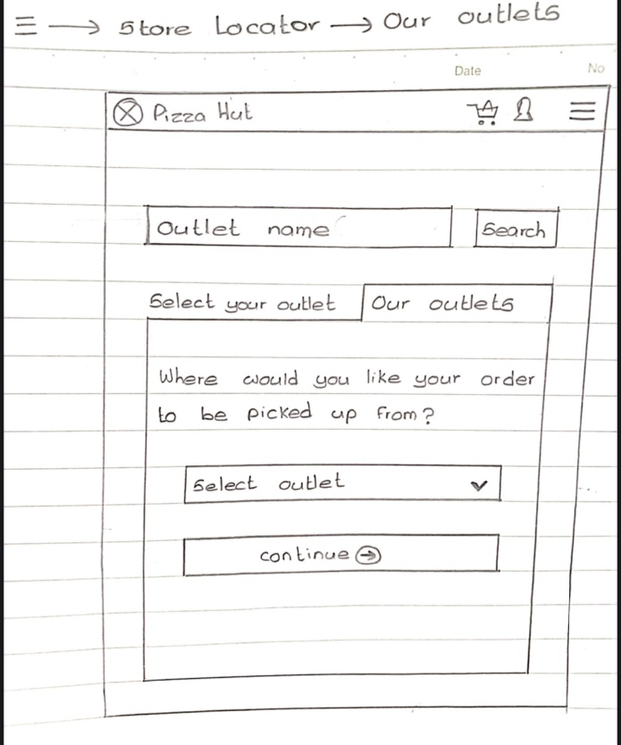Our outlets
2. Check-Out

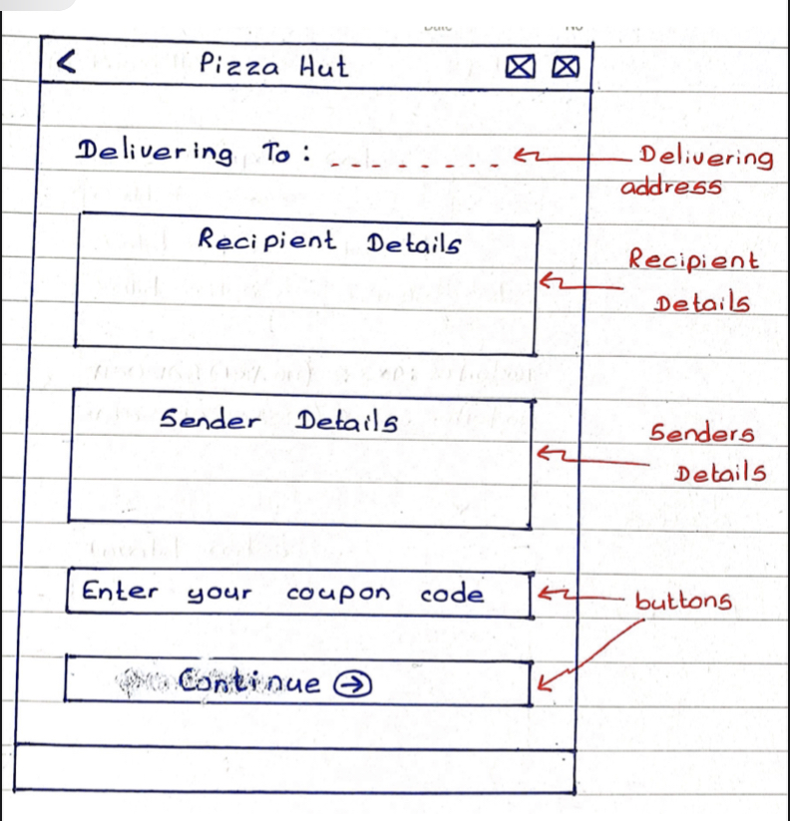

1. 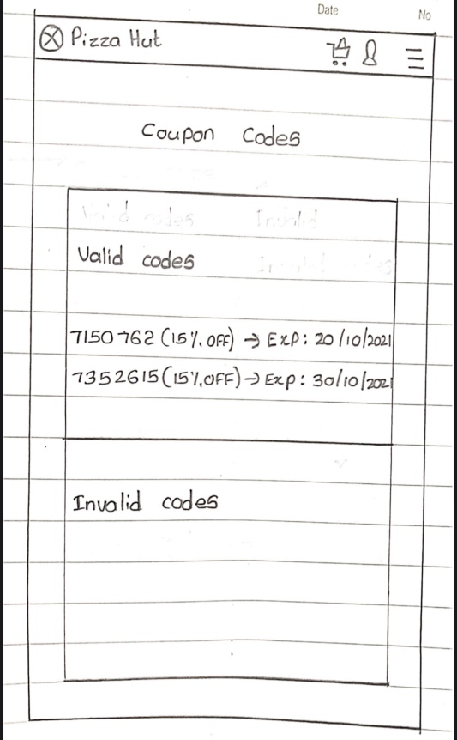Coupon codes

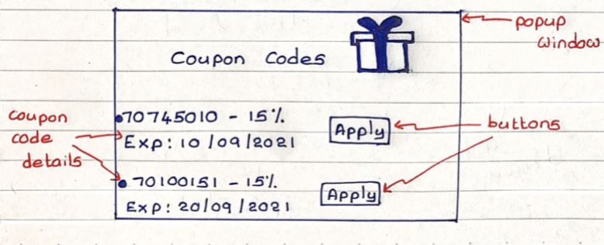

# Wireframes

## IT19014128 (A.M.W.W.R.L. Wataketiya)

Main menu

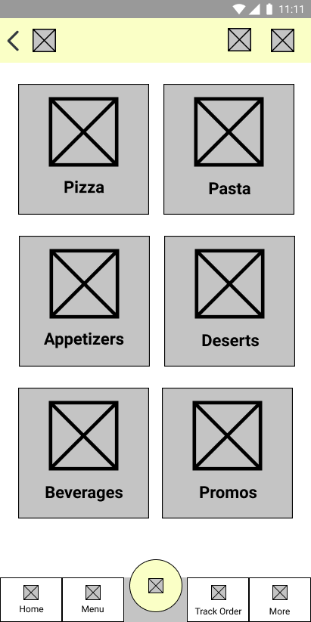

Pizza menu

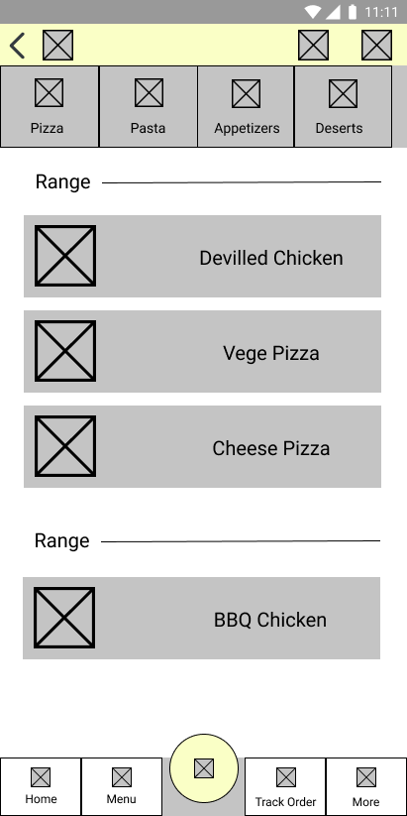

Pizza View

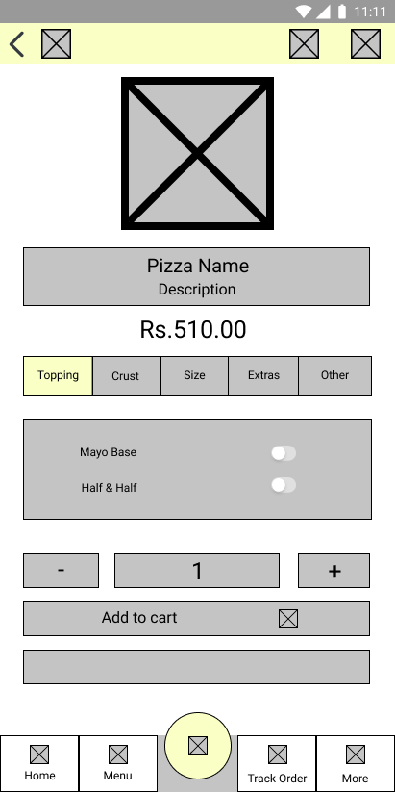

Side panel

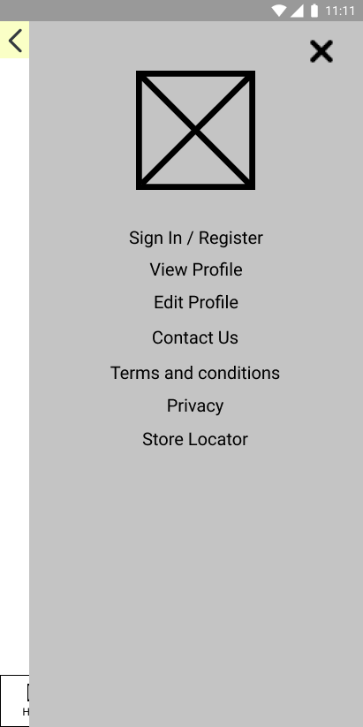

Cart

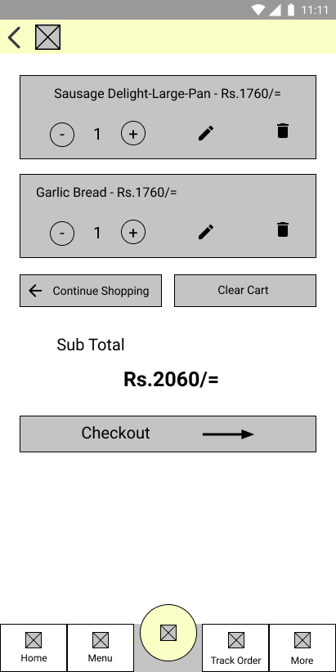

## IT19180526 (S.A.N.L.D. Chandrasiri)

|  |  |
| --- | --- |
| Appetizers Menu | Pastas Menu |
|  |  |

|  |  |
| --- | --- |
| Desserts Menu | Beverages Menu |
|  |  |

|  |  |
| --- | --- |
| Promos Menu | Appetizers – Add to cart |
|  |  |

|  |  |
| --- | --- |
| Pastas/Dessert/Beverage – Add to cart | Contact us |
|  |  |

Promos – Add to cart

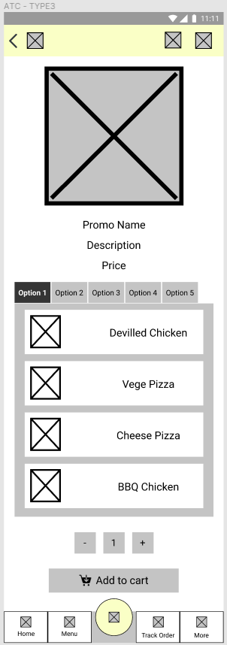

## IT19240848 (H.G. Malwatta)

Splash page (Begin page) Gets started page

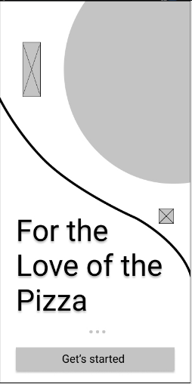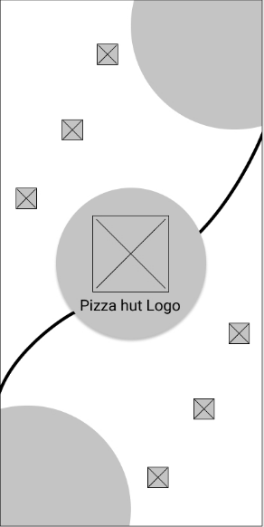

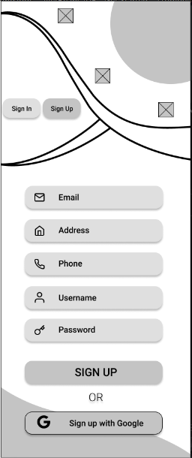Login page Registration page

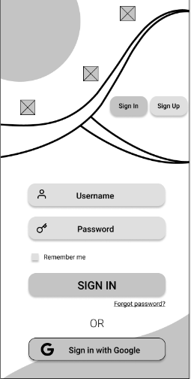

View profile Edit profile

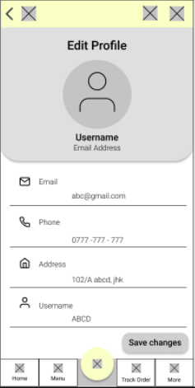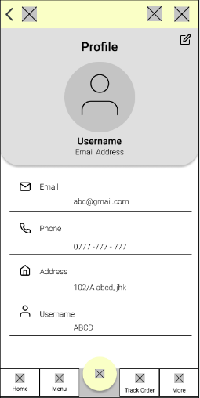

Pop-up message View /Add /Edit /Delete Addresses

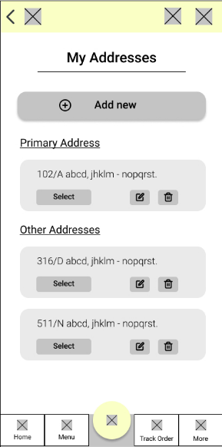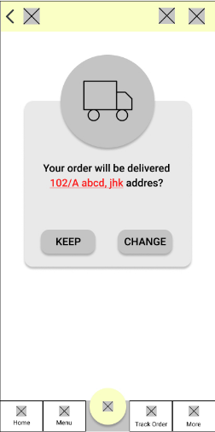

## IT19057248 (G.L.I.R. Liyanage)

Wireframes

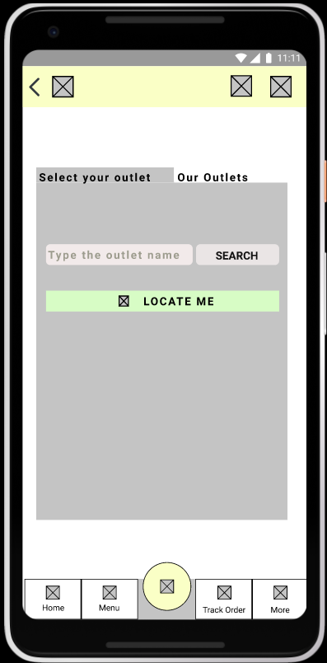 1.Store Locator 2.Select your outlet

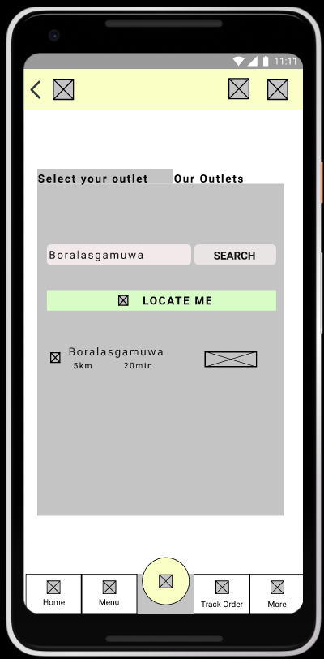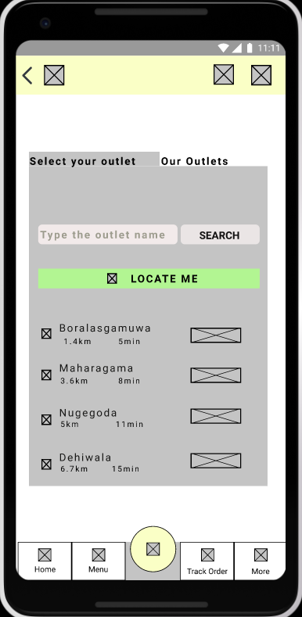 3.Search outlet 4.Locate me

5.Our outlets 6.CheckOut

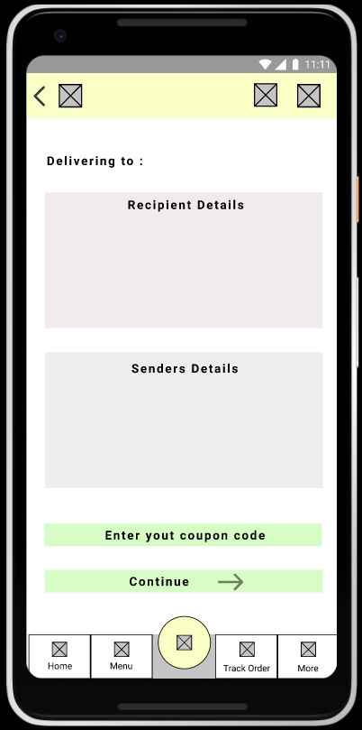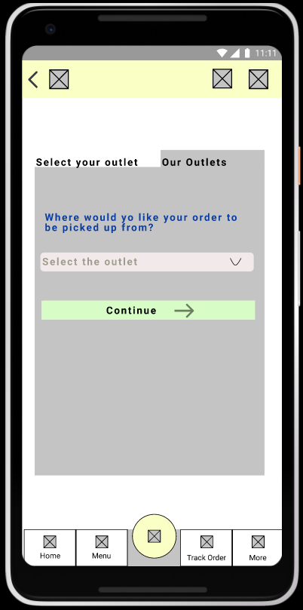

7.Coupon codes

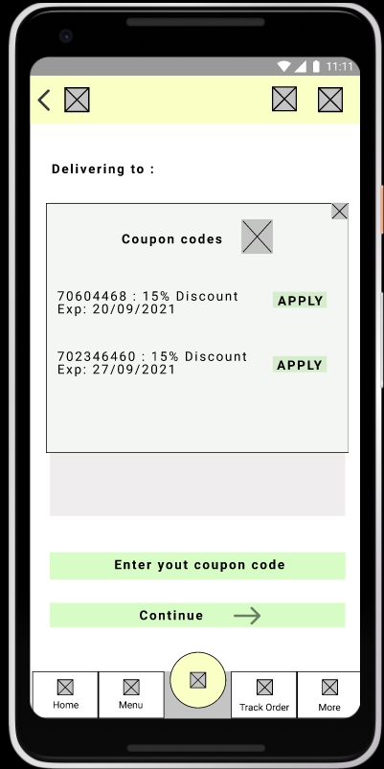

# Prototype Version 1

[Link to figma Prototype 1](https://www.figma.com/proto/KWycYV4ICeELE0yREqLEdM/Prototype?node-id=30%3A991&viewport=288%2C48%2C0.07&scaling=scale-down&starting-point-node-id=106%3A2228&show-proto-sidebar=1)

[Link to entire figma project](https://www.figma.com/file/KWycYV4ICeELE0yREqLEdM/Prototype?node-id=30%3A991)

## IT19014128 (A.M.W.W.R.L. Wataketiya)

Main menu

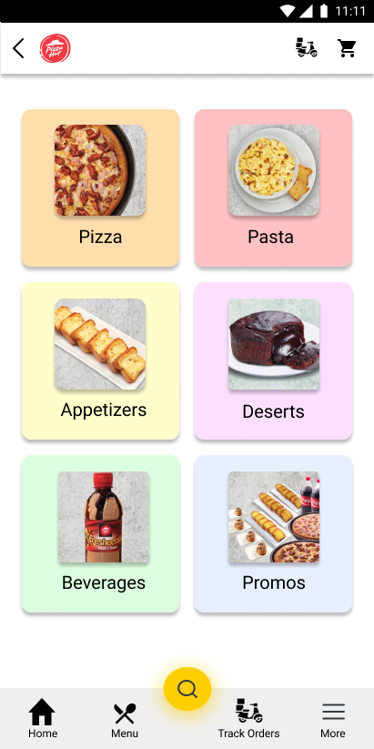

Pizza Menu

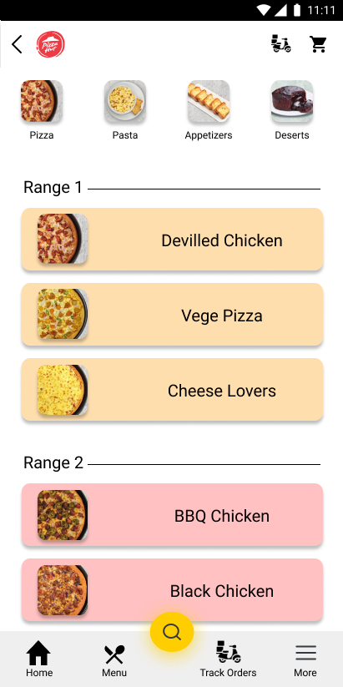

Pizza View

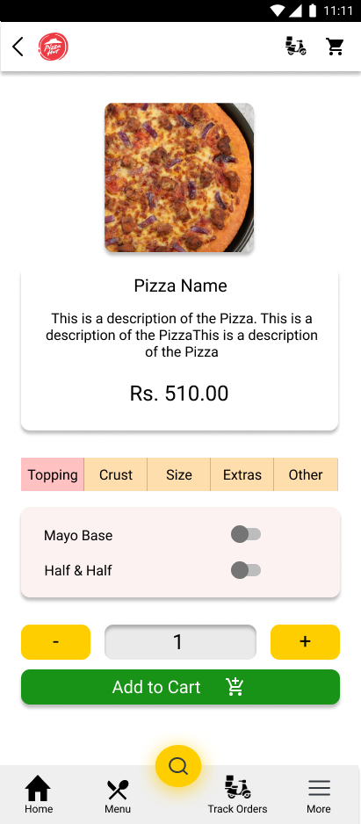

Side panel

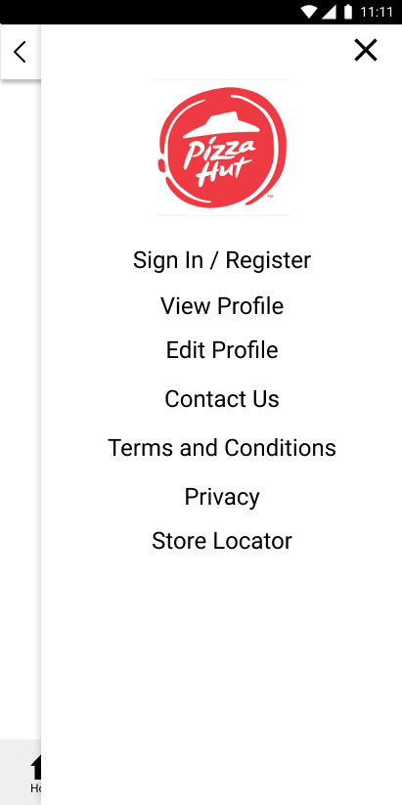

Cart

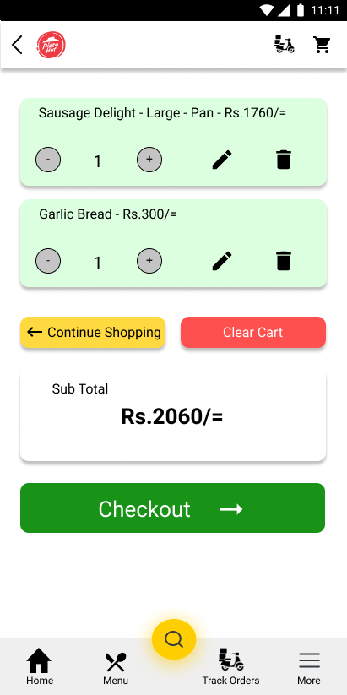

Search

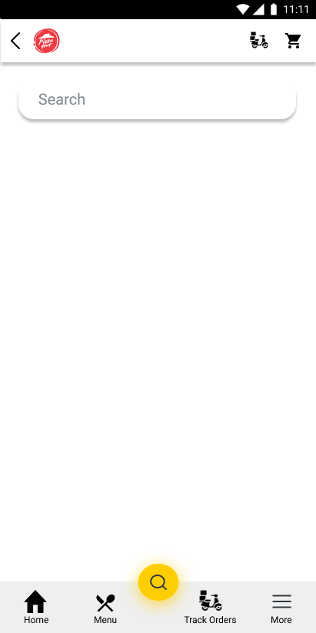

## IT19180526 (S.A.N.L.D. Chandrasiri)

|  |  |
| --- | --- |
| Home | Pastas Menu |
|  |  |

|  |  |
| --- | --- |
| Appetizers Menu | Promos Menu |
|  |  |

|  |  |
| --- | --- |
| Desserts Menu | Beverage Menu |

|  |  |
| --- | --- |
| Appetizers – Add to cart | Appetizers 2 – Add to cart |

|  |  |
| --- | --- |
| Pastas - Add to cart | Dessert – Add to cart |

|  |  |
| --- | --- |
| Beverage – Add to cart | Promos – Add to cart |

|  |  |
| --- | --- |
| Contact us 1 | Contact us 2 |

Contact us 3

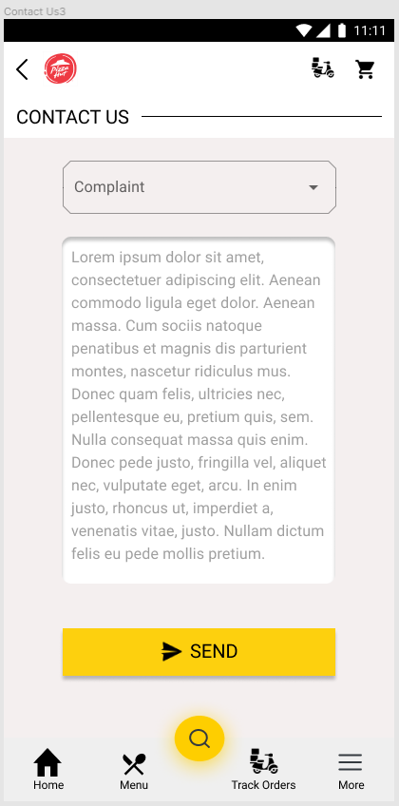

## IT19240848 (H.G. Malwatta)

Splash page (Begin page) Gets started page

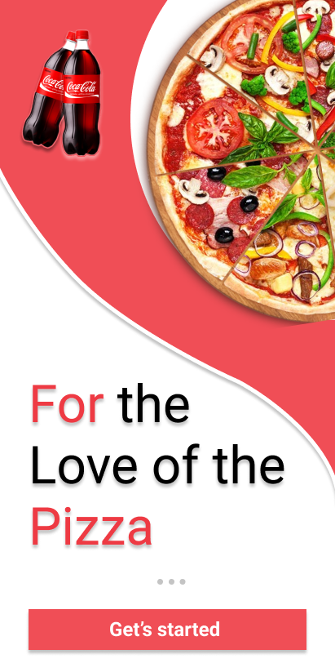

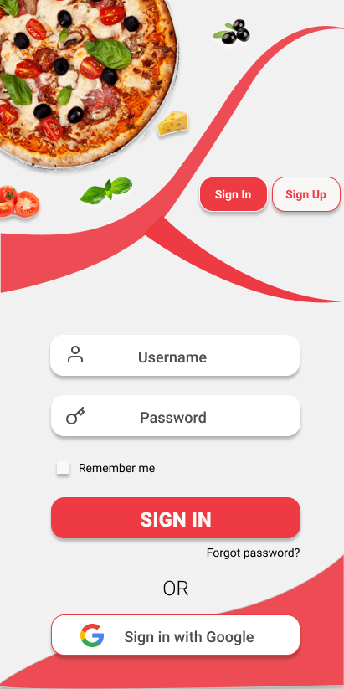Login page Registration page

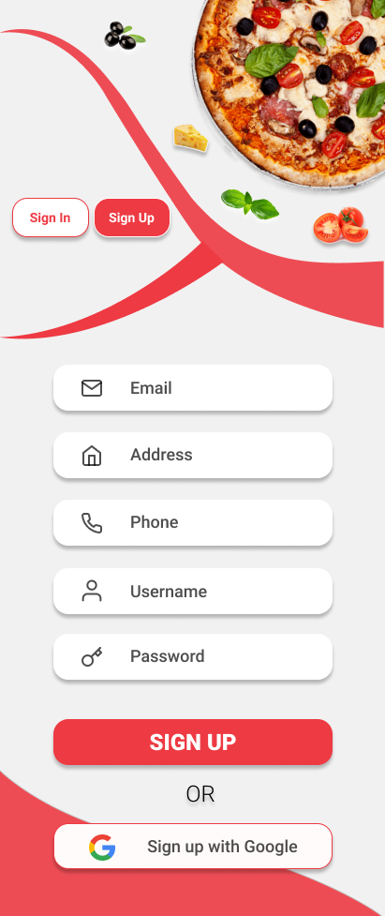

View profile Edit profile

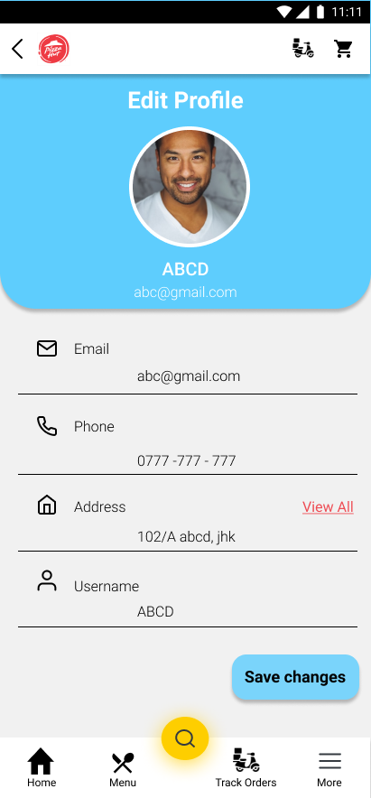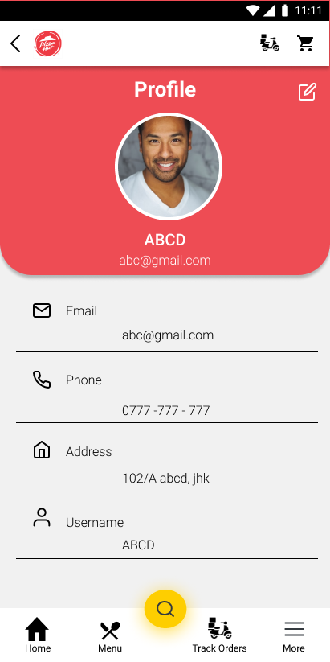

Pop-up message View /Add /Edit /Delete Addresses

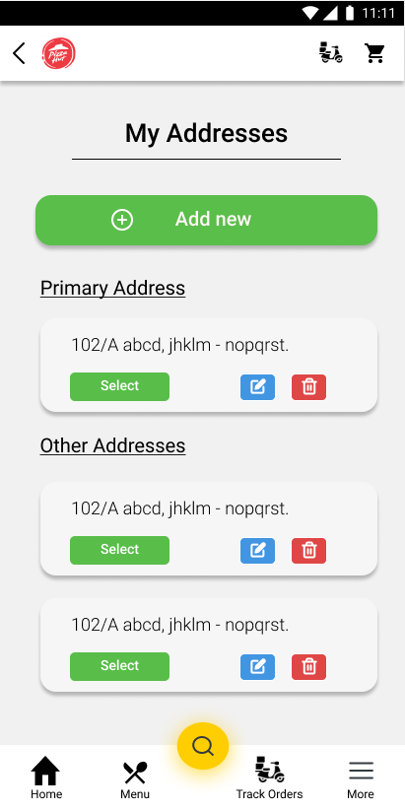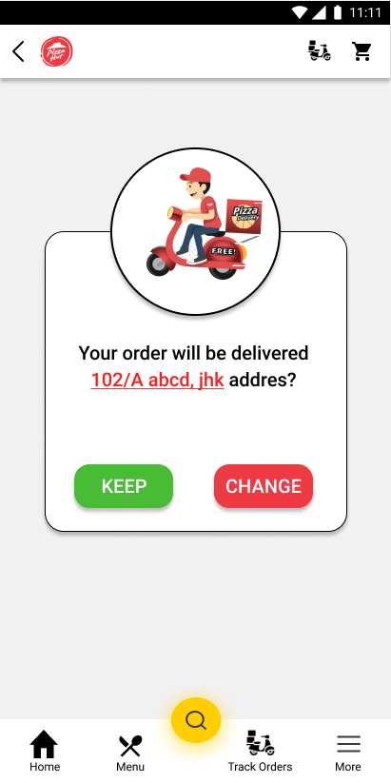

## IT19057248 (G.L.I.R. Liyanage)

Prototypes

1.Store Locater 2. Select your Outlet 3. Search outlets

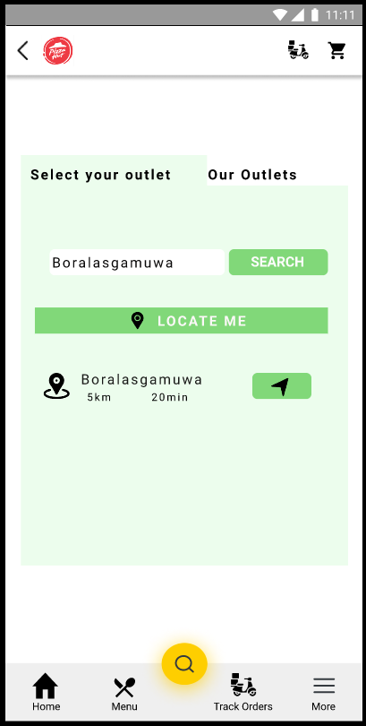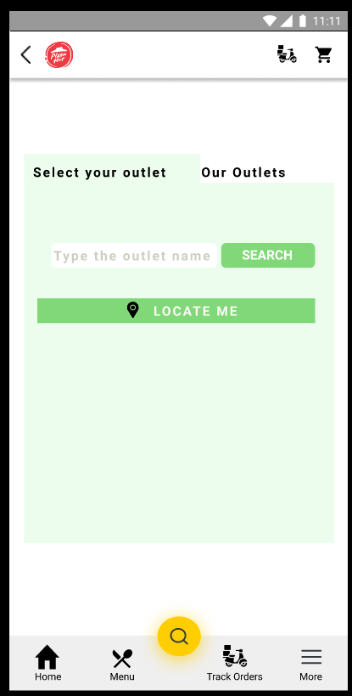

4. Locate me 5. Our outlets

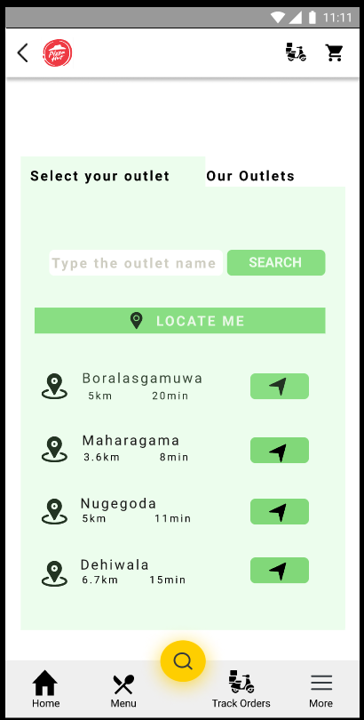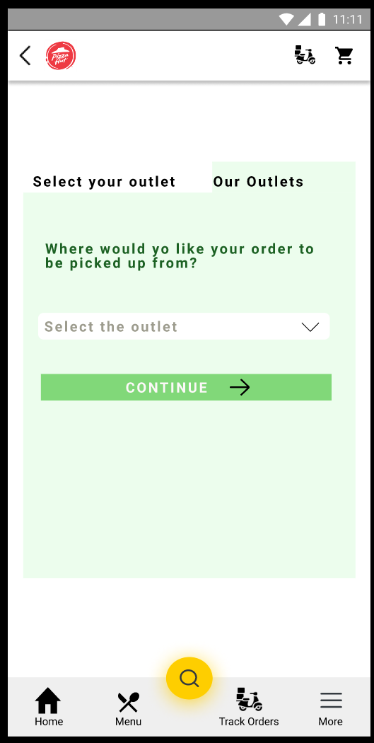

6.Check out 7.Coupon codes

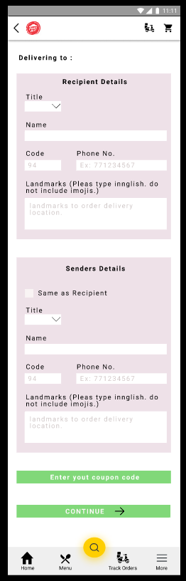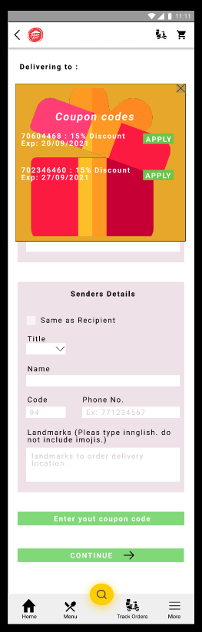

# User feedback

[Links to interview recordings](https://web.microsoftstream.com/video/93917944-9c7e-4c63-93bd-df2a69064e25)

## General

1. What is your opinion on the overall application?
2. Is the color scheme, OK?

## IT19014128 (A.M.W.W.R.L. Wataketiya)

Scripts

1. What do you think of the main menu?
2. Do you suggest any improvements to the main menu?
3. What is your opinion on the pizza menu?
4. Is the pizza menu clear?
5. Do you suggest any improvements to the pizza menu?
6. What do you think of the single pizza view?
7. Is the functionality clear?
8. Do you suggest any improvements to the pizza view?
9. What do you think of the more menu?
10. Is the side panel simple enough? Should it be more stylized?
11. What do you think of the search bar?
12. What do you think of the cart?
13. Do you suggest any improvements to the cart?

## IT19180526 (S.A.N.L.D. Chandrasiri)

Scripts

1. What do you think of the Home?
2. Do you suggest any improvements to Home?
3. What is your opinion on the Pastas menu and “Add to cart” feature?
4. Is the Pastas functionality clear?
5. What is your opinion on the Appetizers menu and “Add to cart” feature?
6. Is the Appetizers functionality clear?
7. What is your opinion on the Dessert menu and “Add to cart” feature?
8. Is the Dessert functionality clear?
9. What is your opinion on the Beverage menu and “Add to cart” feature?
10. Is the Beverage functionality clear?
11. What is your opinion on Promos and “Add to cart” feature?
12. Is the functionality clear?
13. What do you think of Contact us?

## IT19240848 (H.G. Malwatta)

Scripts

1. What do you think of the Splash page (Begin page)?
2. Is that good idea to show gets started page?
3. What do you think of the Login and Registration page?
4. Do you suggest any improvements to Login and Registration page?
5. How about the View profile page?
6. Do you understand to edit the user profile?
7. Can you able to find View Addresses page?
8. Do you suggest any improvements to the Edit profile page?
9. What do you think of the confirmation address pop-up message?
10. Can you able to change your address easily?
11. Do you think that these are user friendly ?

## IT19057248 (G.L.I.R. Liyanage)

Script

* First, I will give you a brief description about my function and how my interfaces work.
* I am working on the store locator function which is needed to select the pickup location or the delivering location, and I’m responsible for saving the coupon code for future use.
* You can go to the store locator page through our menu page, as you can see there are two options inside Store locator. This is a toggle option selection which work inside the same page.
* Click on the “select your outlet” and type any city you want and click on the search button, then you can see all the nearest outlets and the distance. This “select your outlet” button is for the users who needs to pick their orders from the outlet they want.
* When you click on the “locate me” button it will show you all the outlets near you with the distance and you can click on the arrow to see the directions.
* And when you click on the “Our outlets” toggle option there you can select the outlet in the given outlet list and then continue buying pizzas.
* Next function is checking out and adding the coupon code. Inside this check out page it allows the customer to change or keep the delivery address and recipient details. And the users should enter the senders’ details if it is different from the recipient details, if not you can tick on the “same as recipient”.
* As you can see there is an option for entering the coupon code, once you click on the “Enter coupon code” button it will show you a pop-up screen like this. Inside this you have all your valid coupon codes, and you can click on the “apply” button and it will be added to the final calculations.
* That is how all these pages work and, I would like to know if there is any design changes or functional changes you want to suggest?
* Do you think that these are user-friendly?

# Prototype version 2

## IT19014128 (A.M.W.W.R.L. Wataketiya)

[Link to figma prototype version 2](https://www.figma.com/proto/KWycYV4ICeELE0yREqLEdM/Prototype?node-id=184%3A3239&viewport=288%2C48%2C0.13&scaling=scale-down&starting-point-node-id=184%3A3251&show-proto-sidebar=1)

[Link to entire figma project](https://www.figma.com/file/KWycYV4ICeELE0yREqLEdM/Prototype?node-id=184%3A3239)

Main Menu

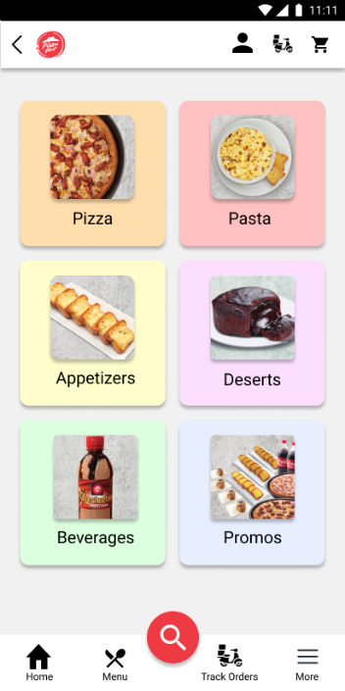

Pizza Menu

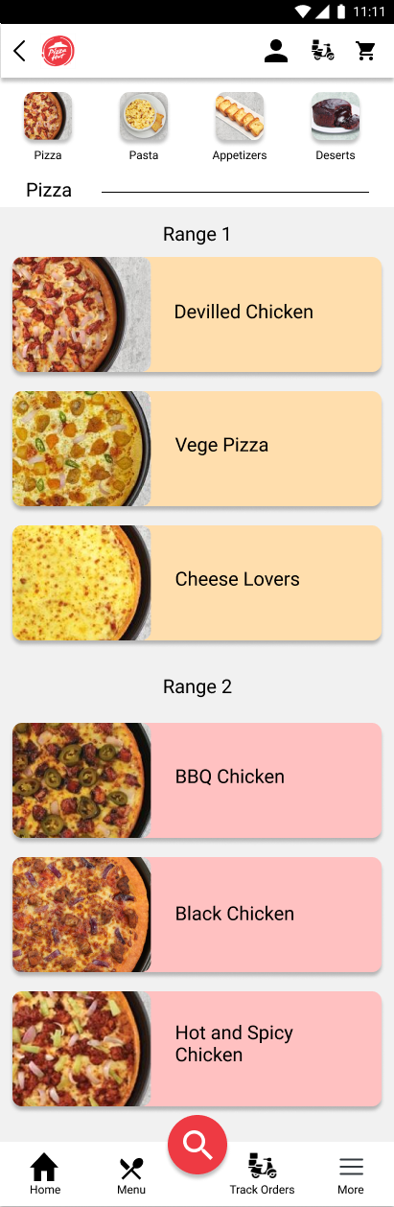

Pizza View

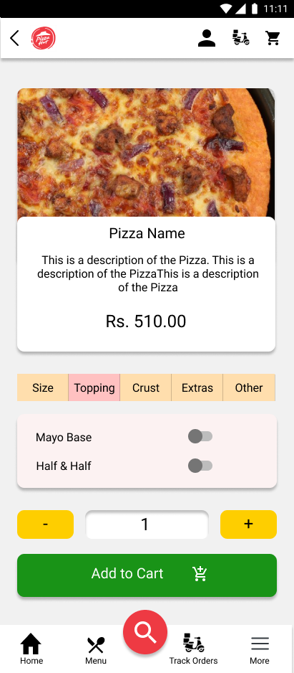

Side Panel

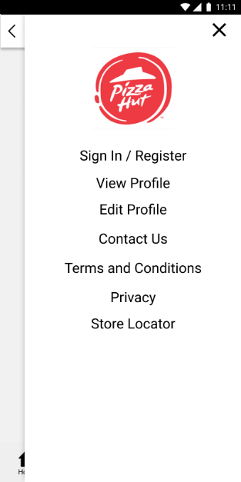

Search

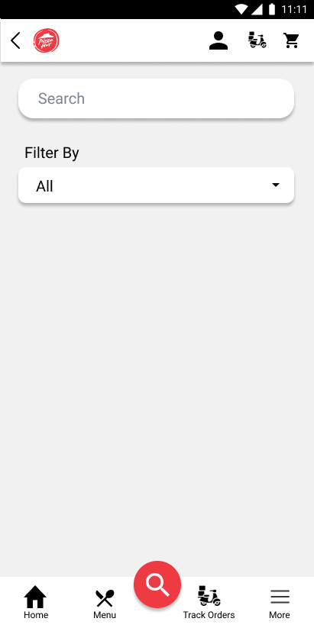

## IT19180526 (S.A.N.L.D. Chandrasiri)

|  |  |
| --- | --- |
| Home | Pastas Menu |
|  |  |

|  |  |
| --- | --- |
| Appetizers Menu | Promos Menu |
|  |  |

|  |  |
| --- | --- |
| Desserts Menu | Beverage Menu |

|  |  |
| --- | --- |
| Appetizers – Add to cart | Appetizers 2 – Add to cart |

|  |  |
| --- | --- |
| Pastas - Add to cart | Dessert – Add to cart |

|  |  |
| --- | --- |
| Beverage – Add to cart | Promos – Add to cart |

|  |  |
| --- | --- |
| Contact us | Feedback 1 |

|  |  |
| --- | --- |
| Feedback 2 | Feedback 3 |

## IT19240848 (H.G. Malwatta)

Splash page (Begin page) Gets started page



Login page Registration page



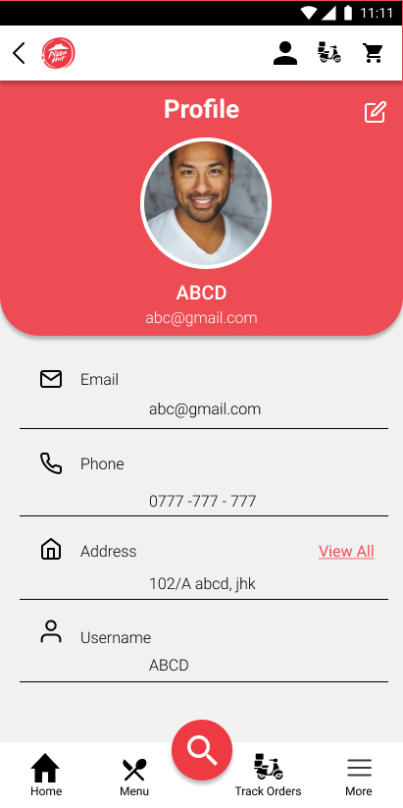View profile Edit profile

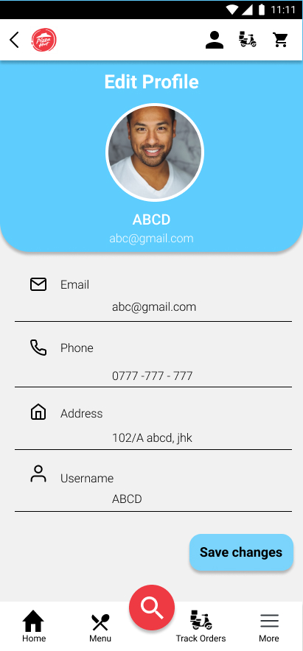

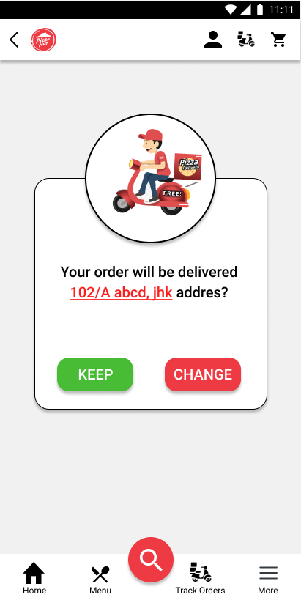Pop-up message View /Add /Edit /Delete Addresses

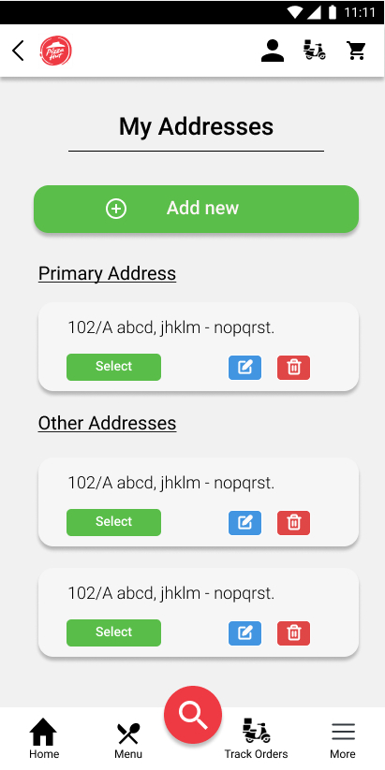

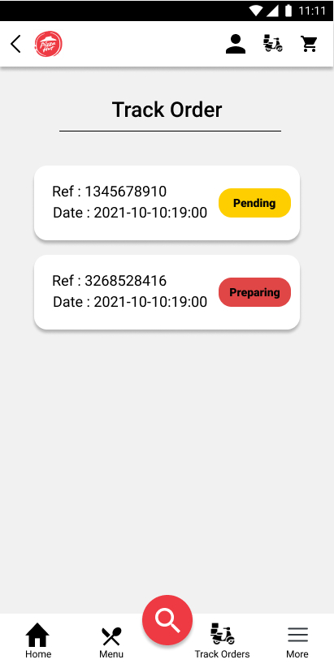Track order

## IT19057248 (G.L.I.R. Liyanage)

Prototype version 2

1.Store locater 2.Select your outlet

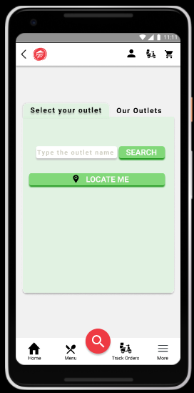



3.Search outlet 4.Locate me

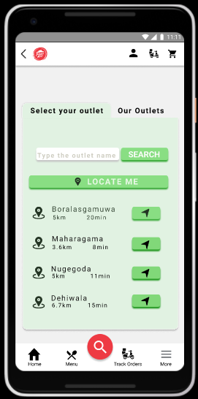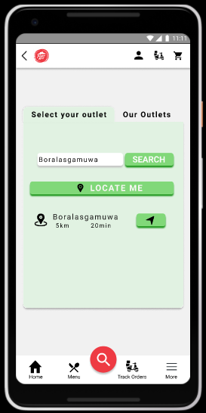

5.Our outlet 6.CheckOut

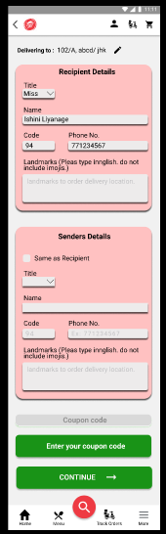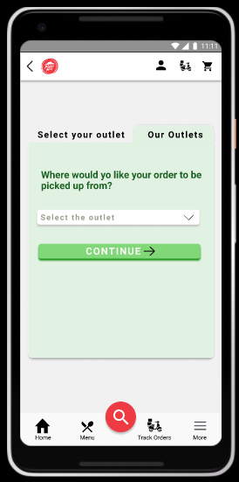

7.Coupon code 8.Checkout after adding coupon codes

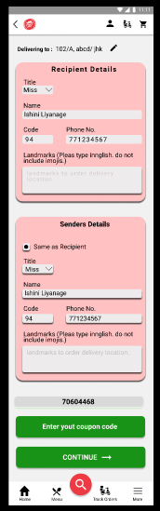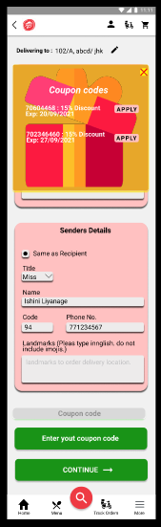

# Contributions

|  |  |  |
| --- | --- | --- |
| Registration Number | Name | Contributions |
| IT19014128 | A.M.W.W.R.L. Wataketiya | Main menu, Pizza menu, pizza view, cart, side panel, search page related sketches, wireframes, prototypes and interviewing for feedback. |
| IT19180526 | S.A.N.L.D. Chandrasiri | Home, menus and single views for appetizers, deserts, pastas, beverages, promos, contact us, feedback related sketches, wireframes, prototypes and interviewing for feedback. |
| IT19240848 | H.G. Malwatta | Splash screen, get started screen, login, registration, address confirmation, address list, track order, view profile, edit profile related sketches, wireframes, prototypes and interviewing for feedback and edit and merge the interview video. |
| IT19057248 | G.L.I.R. Liyanage | Store locator, checkout, coupon code related sketches, wireframes, prototypes and interviewing for feedback. |